WPF

WPF – Windows Presentation Foundation, it is introduced in .Net framework 3.0.

Wpf using for wise user interface/UI (3D, animation, themes etc.) with minimum code complexity.

**Features:**

1. **Data Binding**
2. **Dependency Properties**
3. **Styles**
4. **Theme**
5. **XAML**

**WPF Architecture:**

1. **Managed layer (dll / libraries/ collection of classes):**

**Presentation core:**

Panels, style controls, layouts. It implements data bindings, animations.

**Presentation Framework:**

Provides 2d, 3d, Visual tree.

**Windows Base:**

Contains elements which can be reused outside of WPF environments alike as dispatcher objects and dependency objects.

1. **Unmanaged layer(dll):**

**MilCore:**

Acts as mediator b/w Wpf and API

**WindowsCodec:**

Responsible for what is shown in display.

1. **OS Core elements:**

Device drivers, CLR, GDI(Render).

**XAML:**

Extensible Application Markup Language, it is for describing GUI.

During runtime xaml is converted to baml (Binary Application Markup Language) by MSBuild.

(MainWindow.xaml & MainWindow.xaml.cs🡪 constructor MainWindow()🡪 InitializeComponent() method called LoadComponent() method which converted xaml to baml).

MarkUp Extensions are used for styling, denoted within “{}”.

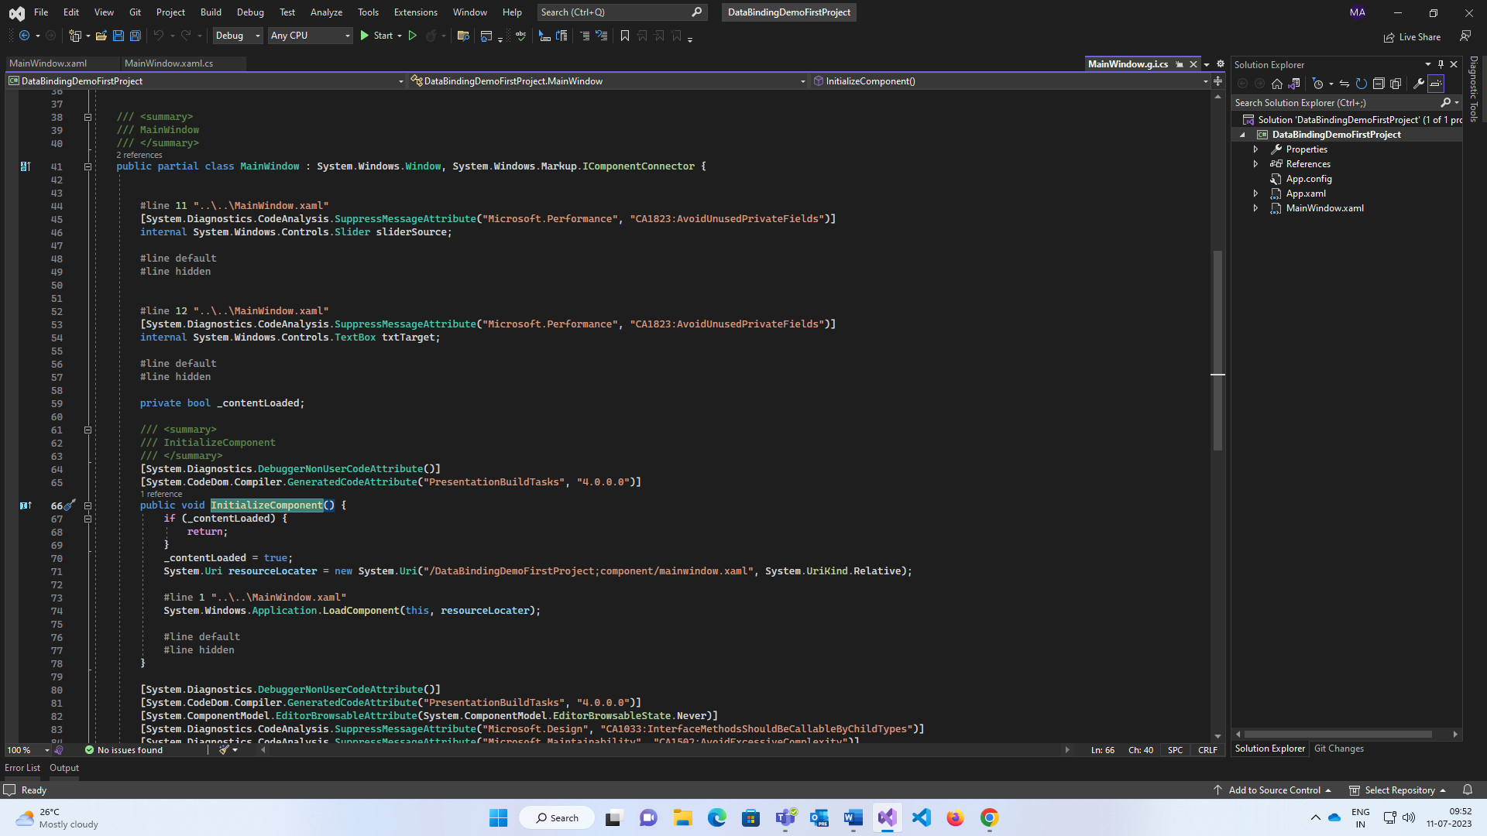

Logical Tree 🡪 window > grid > button.

Visual Tree 🡪 all UI elements shows.

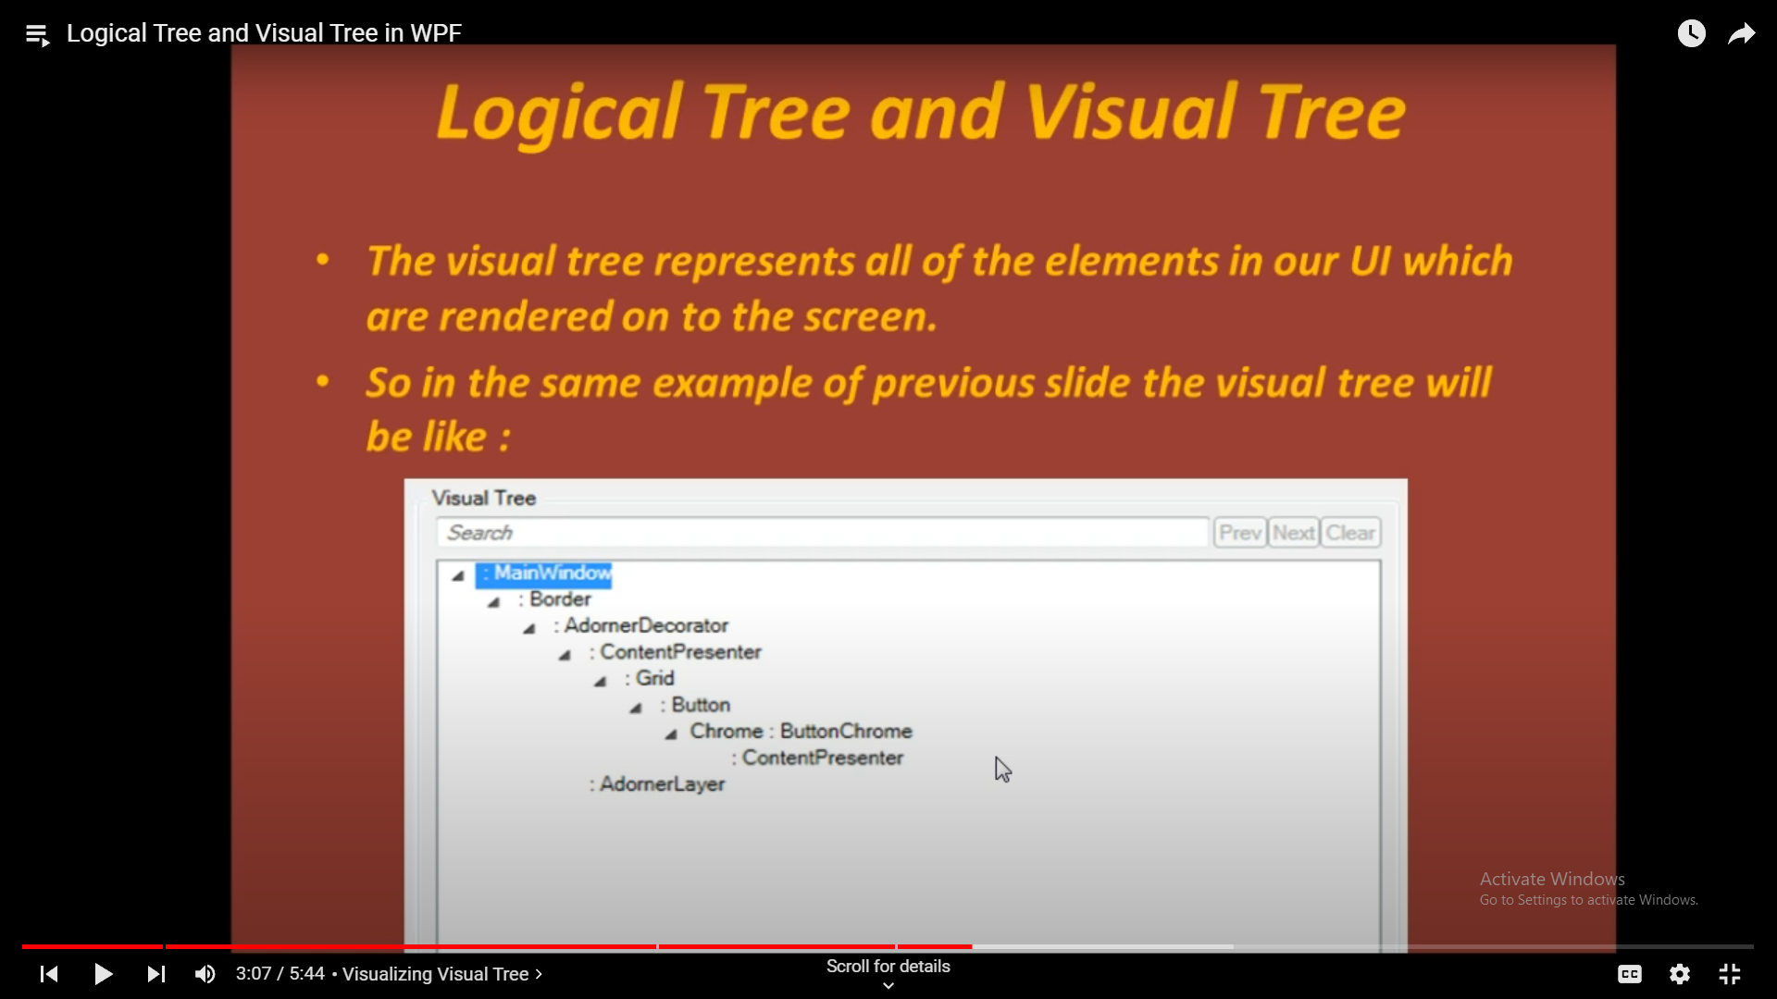

**Layout:**

Panel class is base class for all layout, panel is used to positioning controls.

StackPanel🡪 one over other (Orientation = “Horizontal”) / one after another (Orientation = “Vertical”).

WrapPanel🡪 wrapped one after another (changed with size of UI).

Canvas🡪 changed controls to desired positions (Canvas.Top, Canvas.Left)

DockPanel🡪 Position the elements alike as div(Dvision in html). (Like DockPanel.Dock=”Top”/

DockPanel.Dock=”Right”/ DockPanel.Dock=”Bottom”)

Grid🡪 arranged controls with rows and columns.

**Observable Collection:**

Maintaining collection of objects in WPF, in WPF for constantly needs notification from the behind code we use **ObservableCollection** to notify the WPF UI automatically. It presents in **System.Collection.ObjectModel** namespace.

ObservableCollection implements **INotifyCollectionChanged** and **INotifyPropertyChanged** and it has **NotifyCollectionChangedEventHandler** and **PropertyChangedEventHandler** events.

**Data Context:**

To binding any element to other element we are actually binding to at the data context property.

Wpf uses a D.P. called as Data Context property to set the source of bindings. If source is not specified by default WPF searches Data context.

There is no default source for Data Context property, it needs to assign some value otherwise binding will be null.

(DataContext = class obj //data source class for mapping ViewModel to MainWindow.cs; )

**Data Binding:**

Normally displaying data we are using data binding.

Where data comes from is called Source and property which need bind the data is called Target (E.g., Textbox, textblock, combobox etc).

Target is always a dependency property and binding is bridge b/w source and Target.

1. One way (Source 🡪 Target)

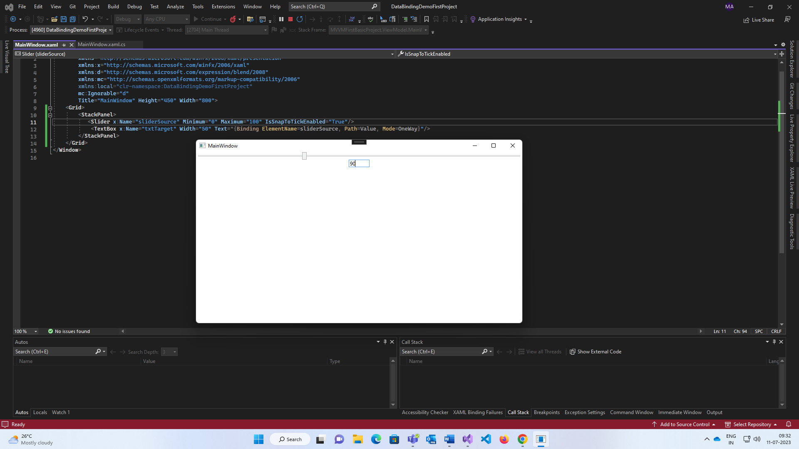

Changing the source then the target will update and vice versa won’t work.

1. Two ways/Default (Source 🡨🡪 Target)

In target (here textbox) we can write UpdateSourceTrigger = PropertyChanged (Only worked with 2 way bindings and by default it is LostFocus Property) for this automatically change the source without pressing tab or enter.

1. One way to source (Source 🡨 Target)

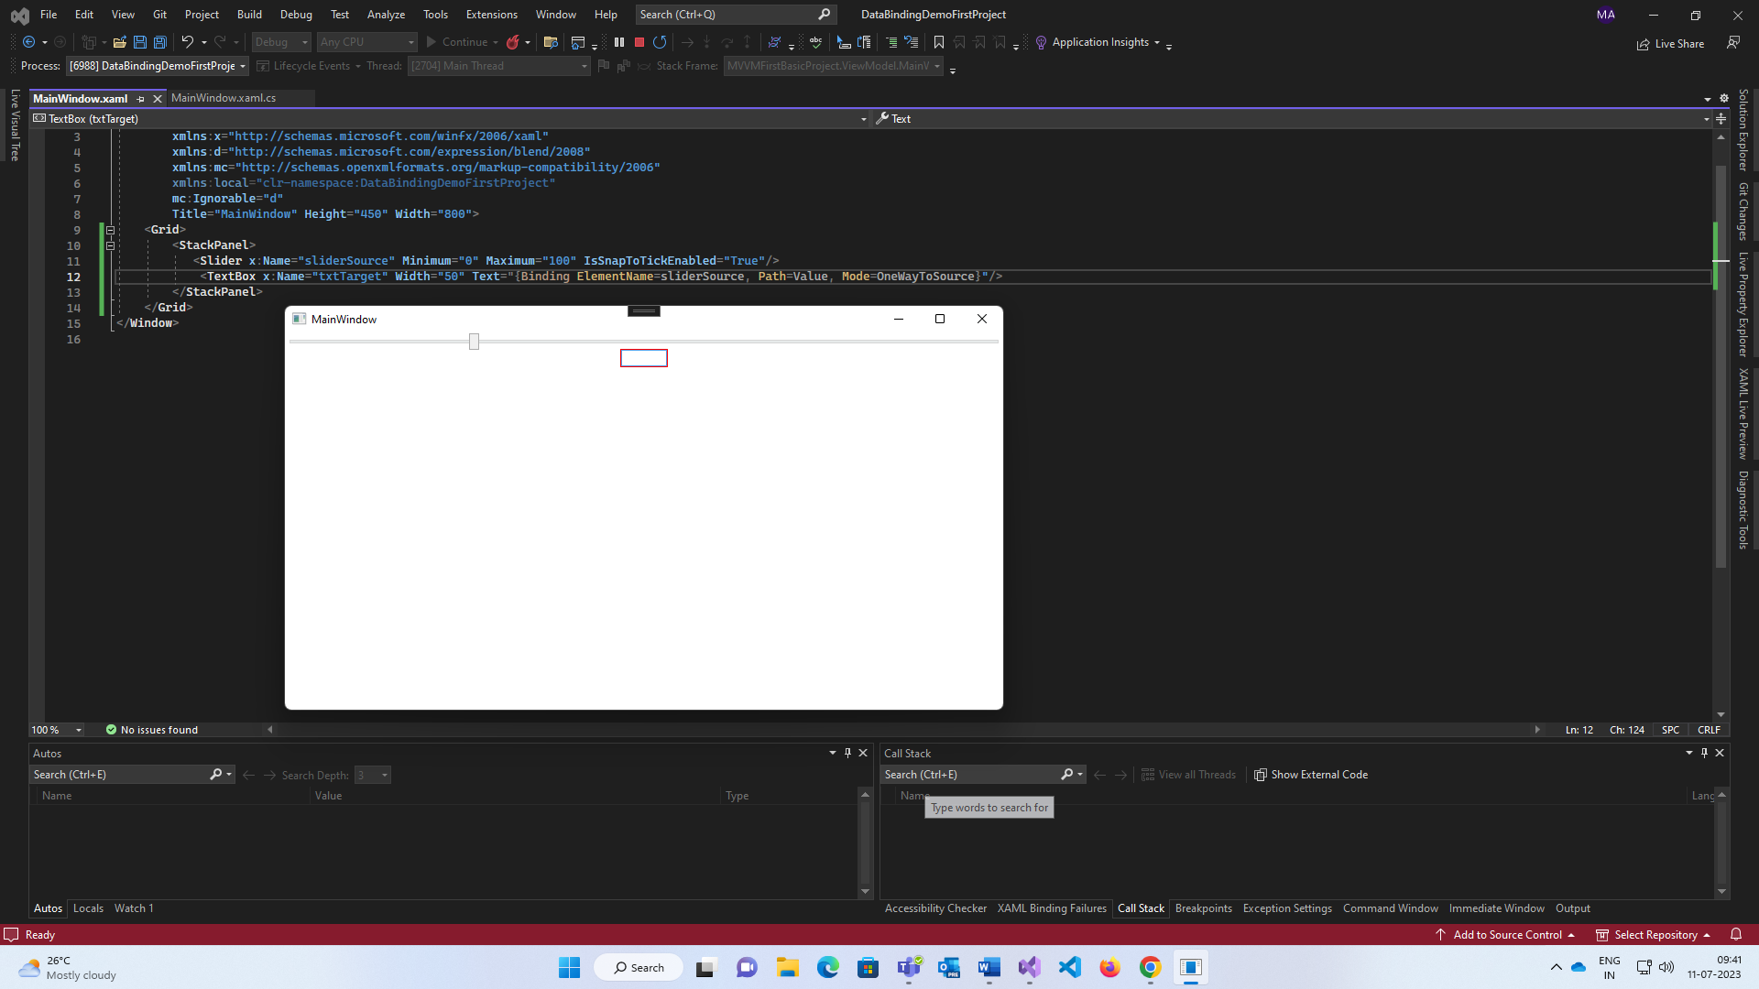

Changing the source but target is not updating.

1. One Time (Only change during runtime only once)

Only works with the Application initialization.

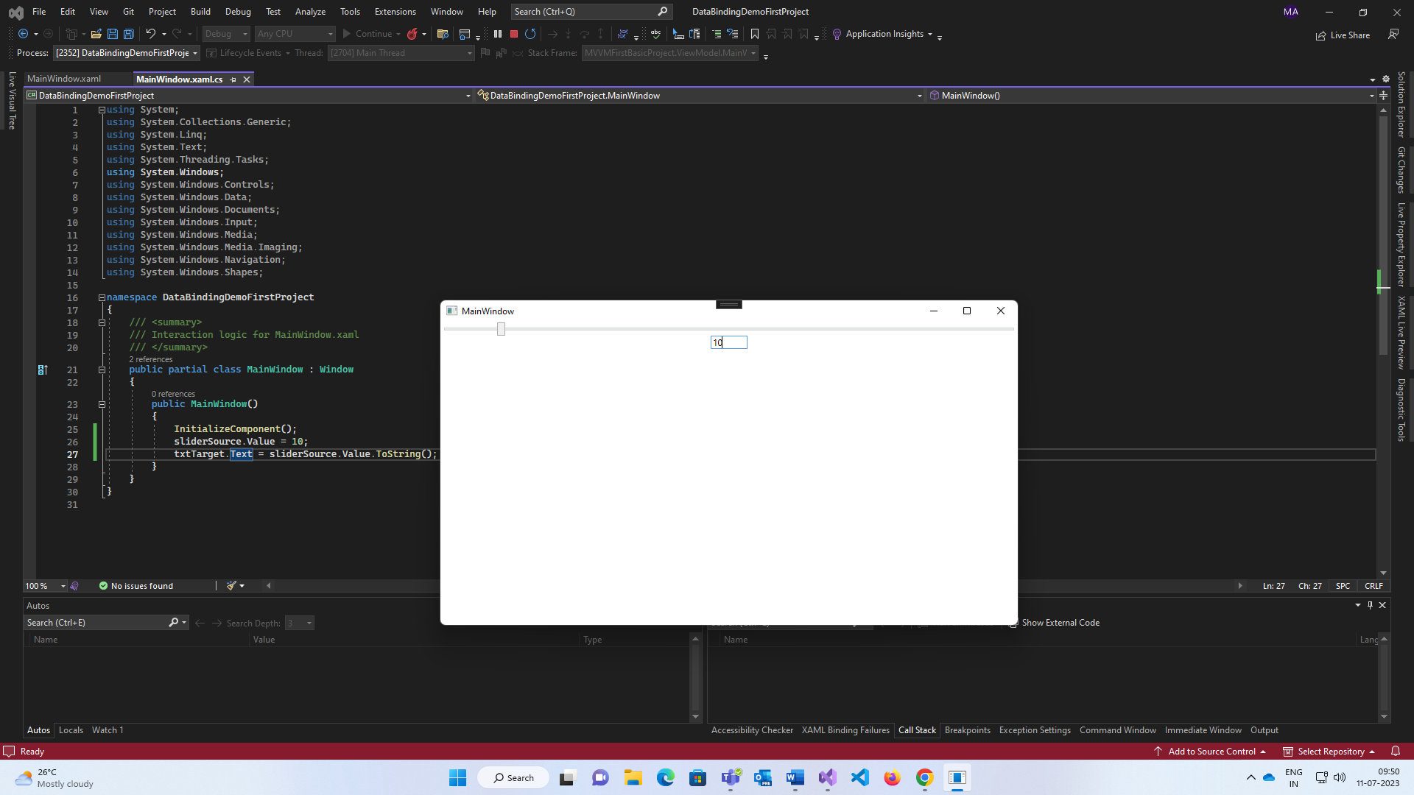

**MVVM:**

**Model – View – ViewModel.**

Separate code and UI with each other.

View is for UI and Model is for classes, properties, methods etc. and ViewModel is bridge b/w model and view.

Depends on XAML and Data binding Concept.

**Commands:**

Loosely typed, avoid code behind and code duplications.

For writing command, implement Interface ICommand which is present in System.Windows.Input,

it has Execute() method which represents the logic of the command or code and

CanExecute() method which has bool return type and represents the condition which command will be fired.

Also it has one event🡪 EventHandler and also it has two delegates(function pointer)

1. Action<object> for invoking Execute method

and

2. Func<object,bool> for invoking CanExecuteMethod.

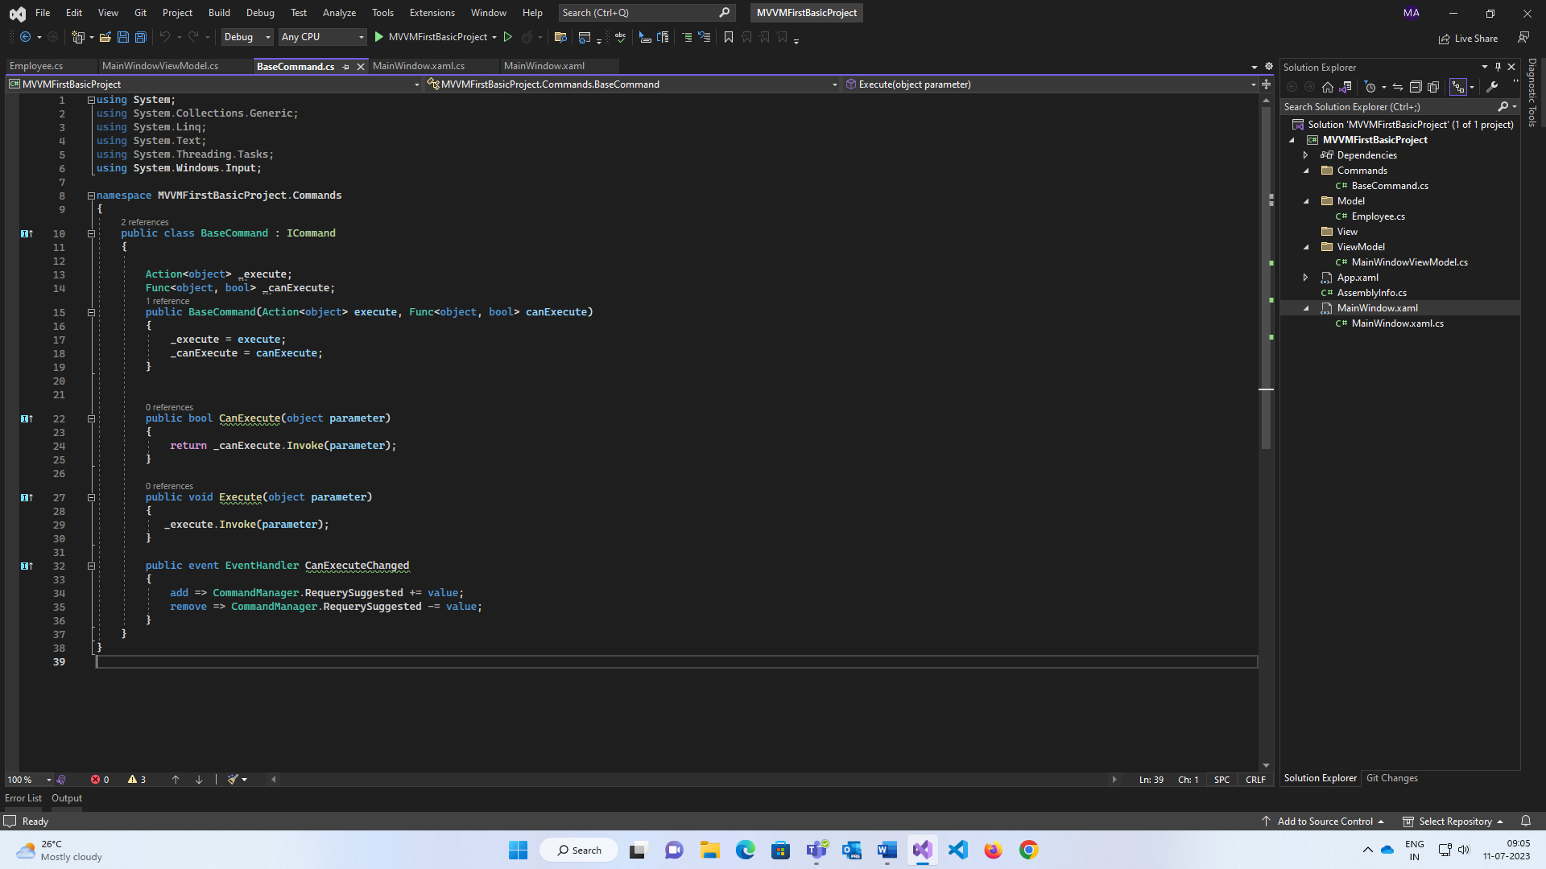

**Routed Events:**

It invokes handler on multiple listeners in an element tree .

1. Direct Event 🡪 Normal CLR event (Click the Button)
2. Bubbling Event 🡪 travels up in Visual tree hierarchy. (Inner button > outer button)

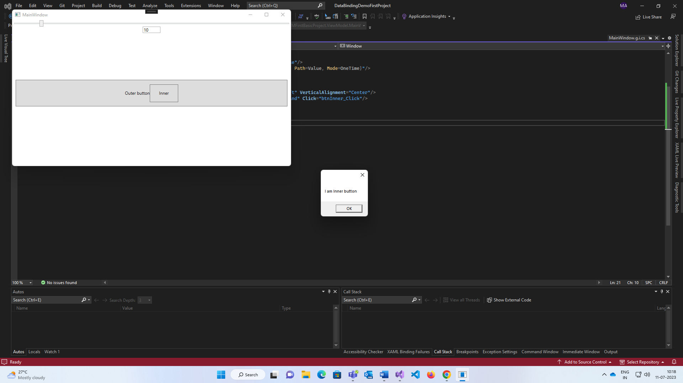

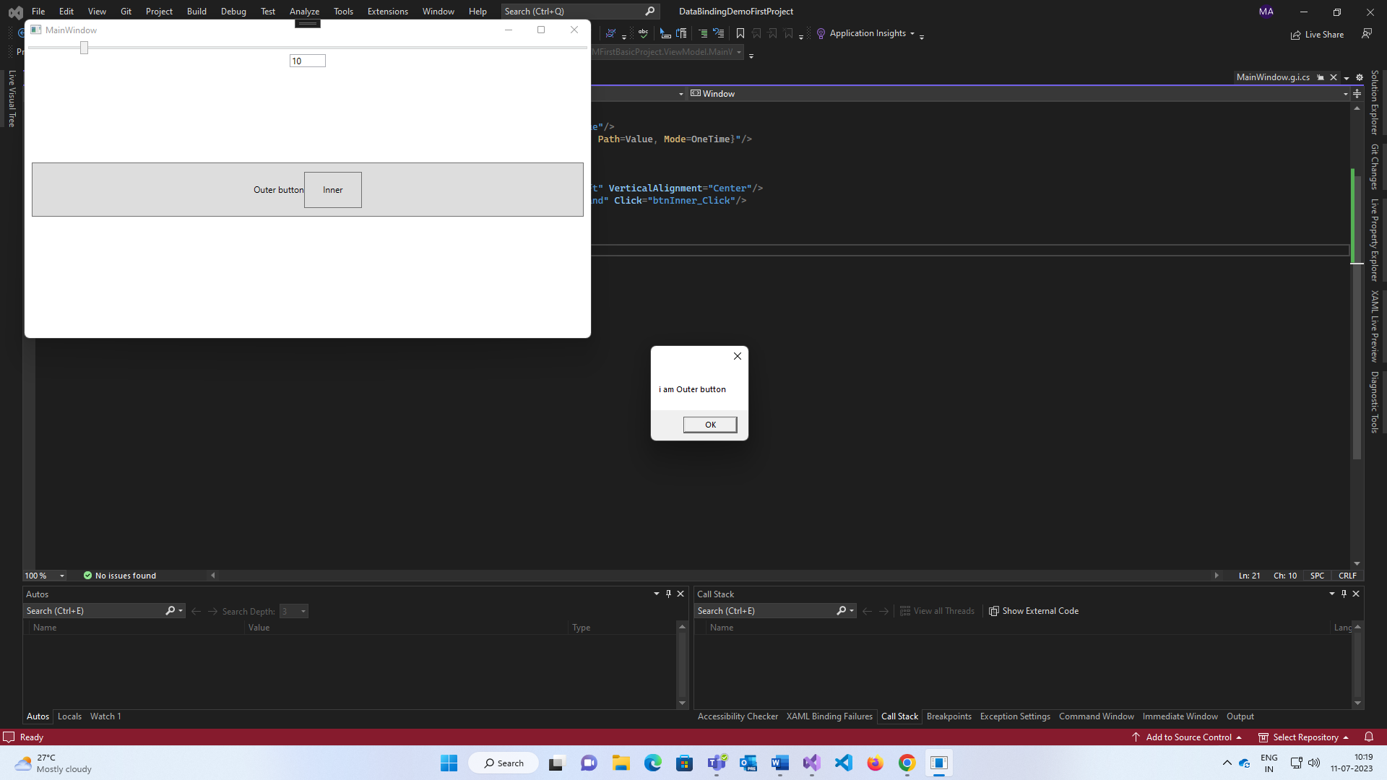

1. Tunnelling Event 🡪 travels down in Visual tree hierarchy, always start with preview. (Outer button > inner button)

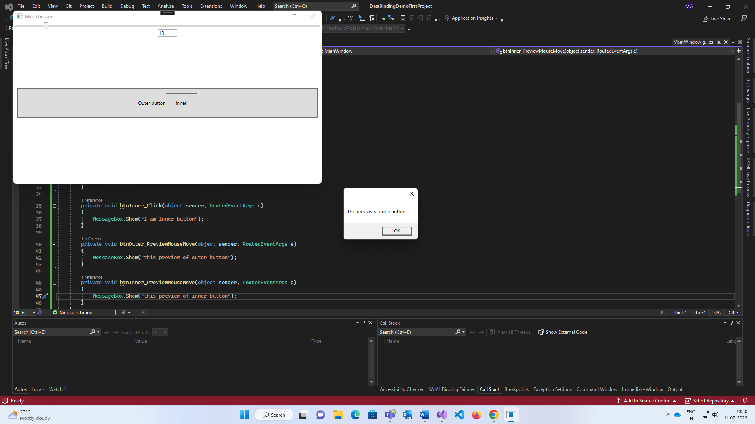

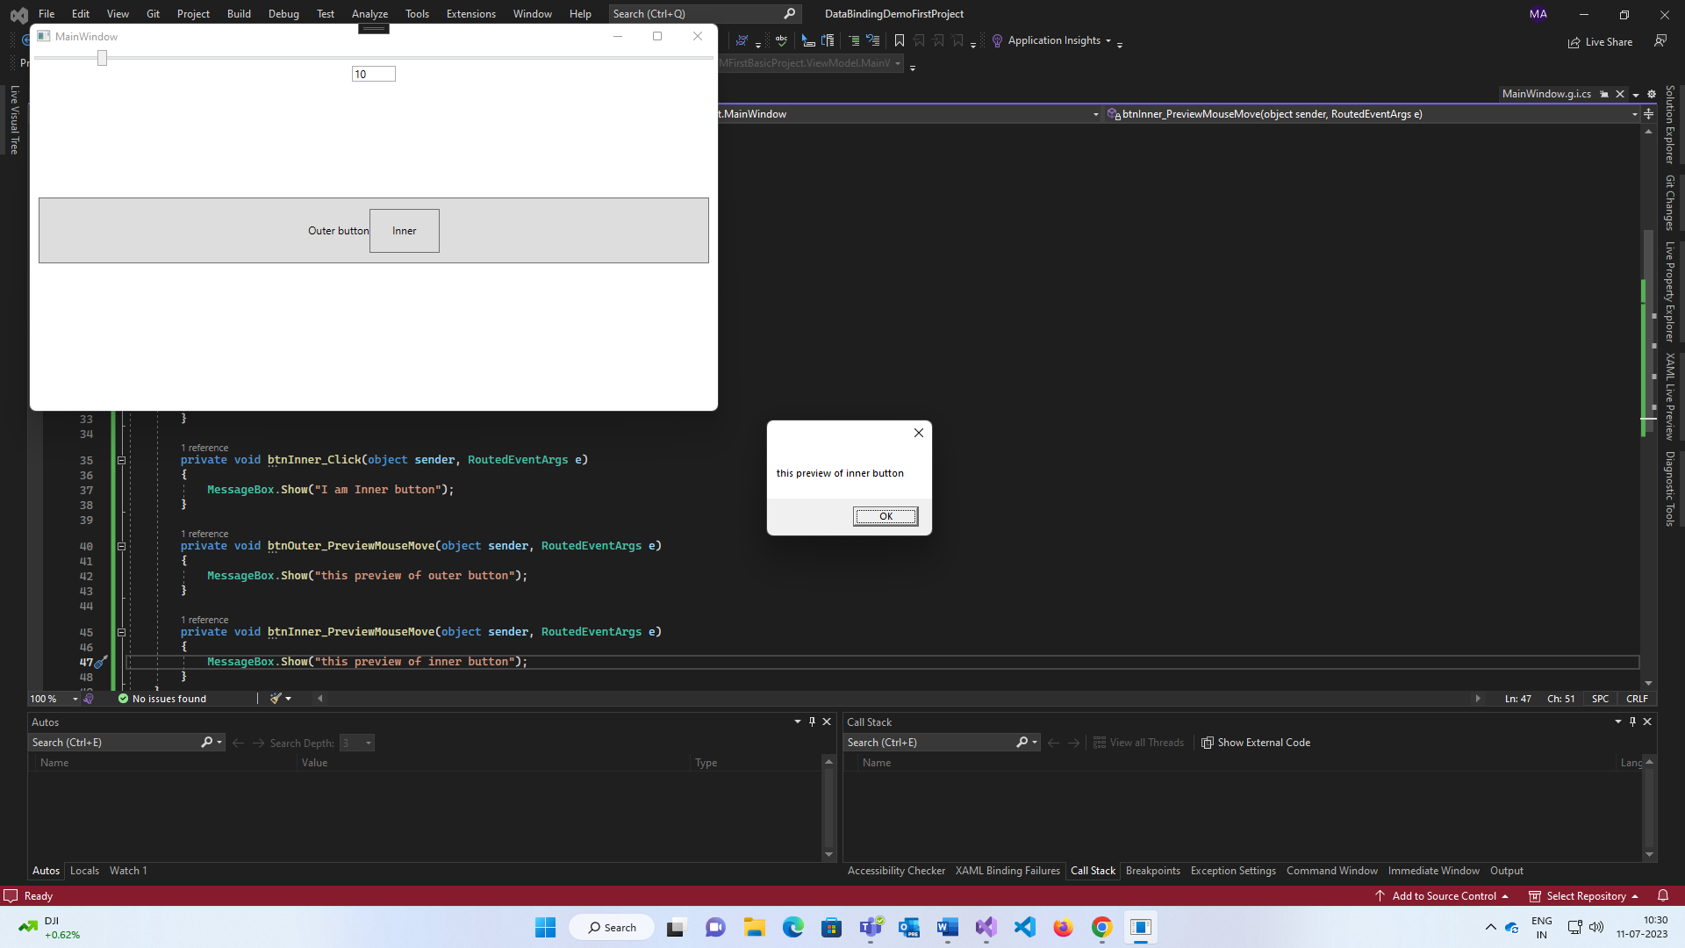

**WPF Resources:**

Data can be stored in resources; alike as styles, triggers, templates etc. it stores in key value pair.

1. StaticResourse (Compile time): The value of the object is set while writing xaml code.

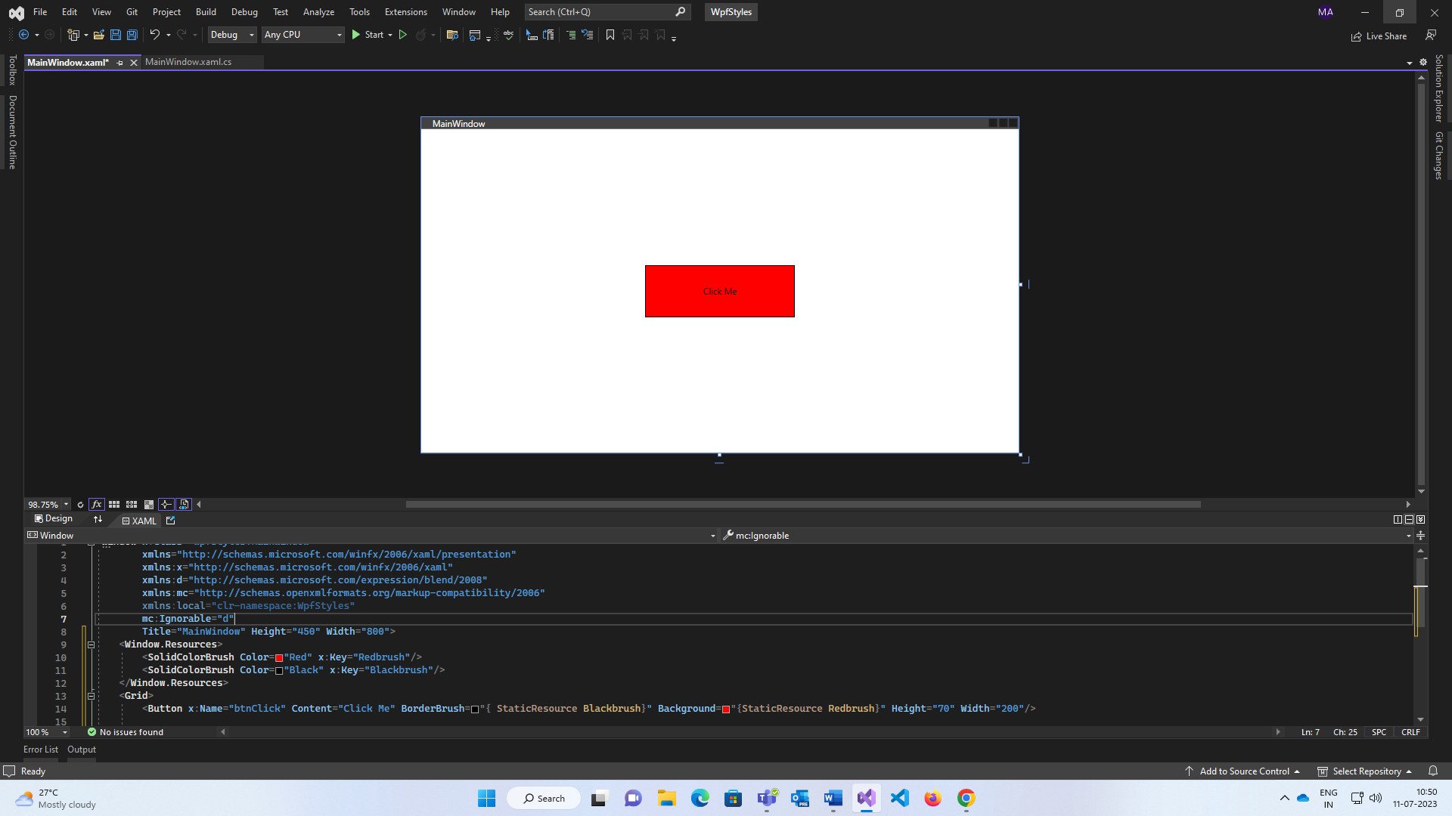

<App.Resources> (can be used in entire application (App.xaml))

<Window.Resources> (can be used in entire window)

<Grid.Resources> (can be used in entire grid)

<x:Key= “KeyName”> with combination {StaticResourse KeyName } MarkUp Extension.

Mostly used for styles, templates etc.

1. Dynamic Resource (Runtime): The value of object is evaluated and stored in an expression and the value is substitute at run time.

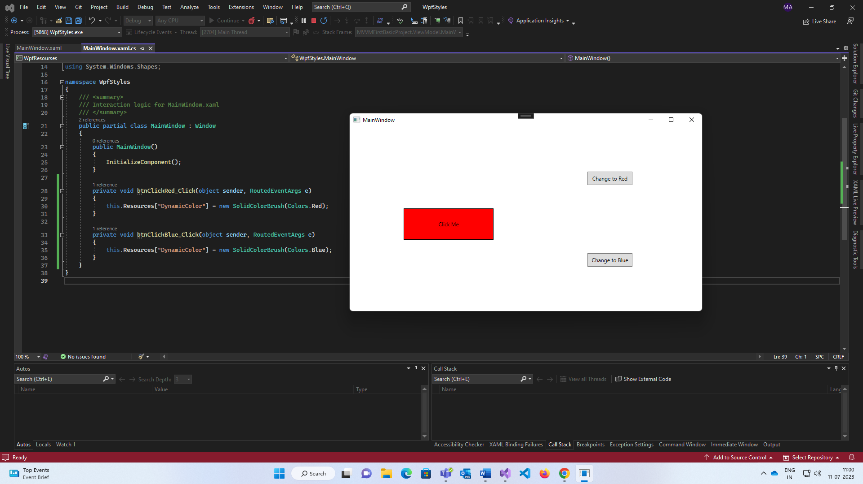

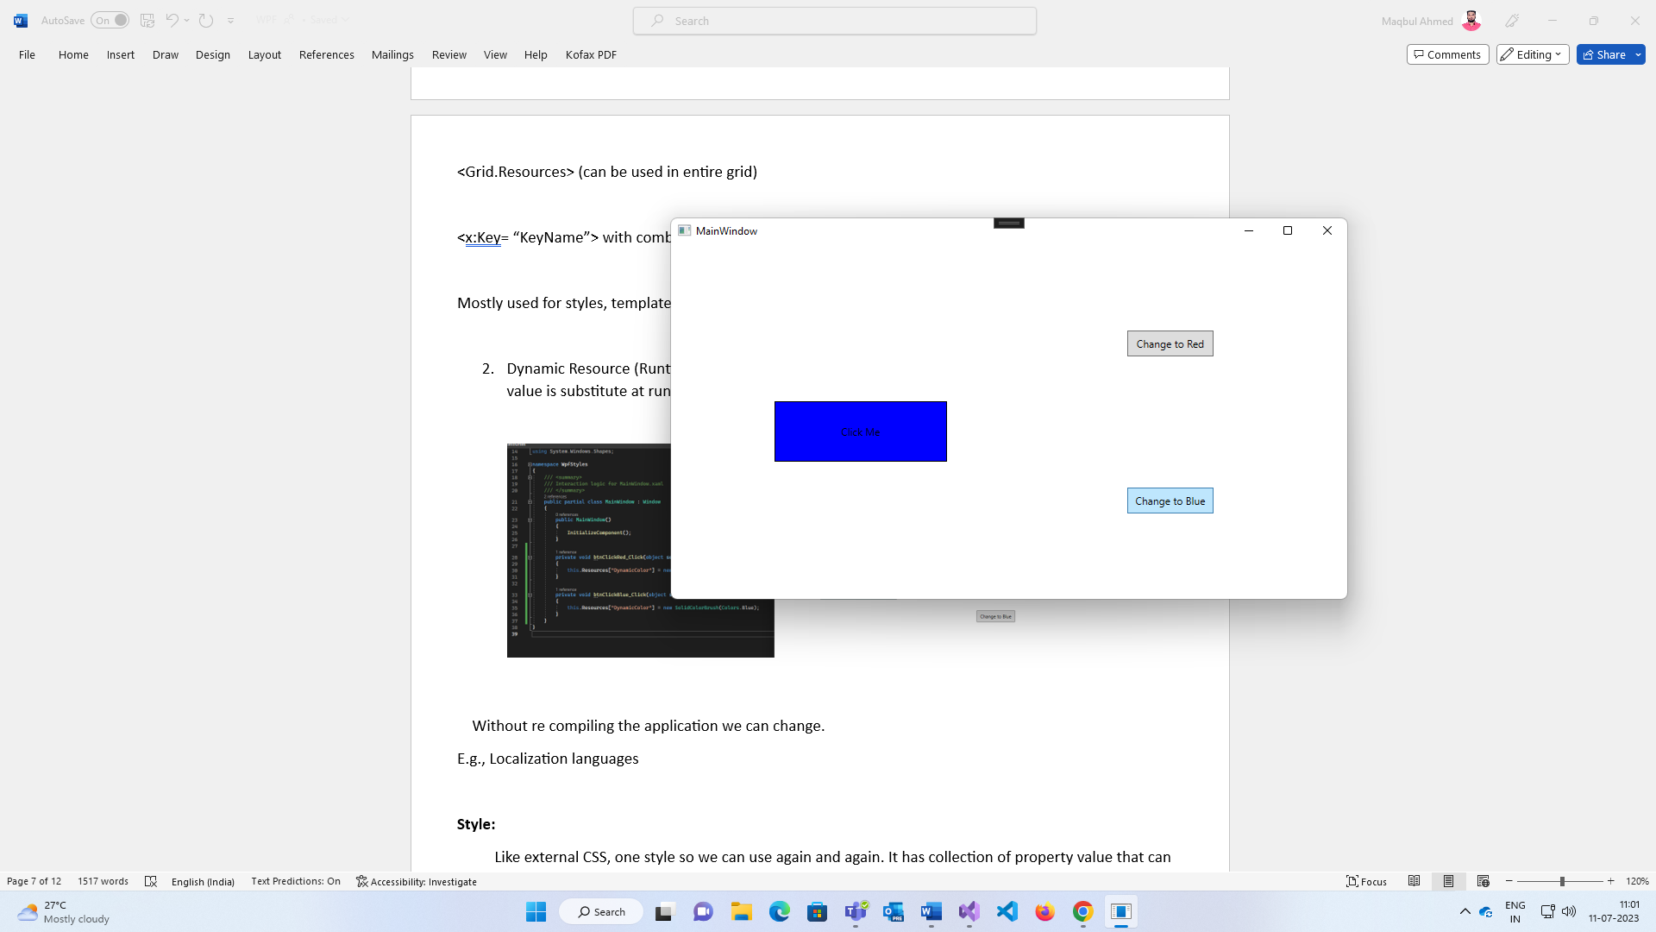

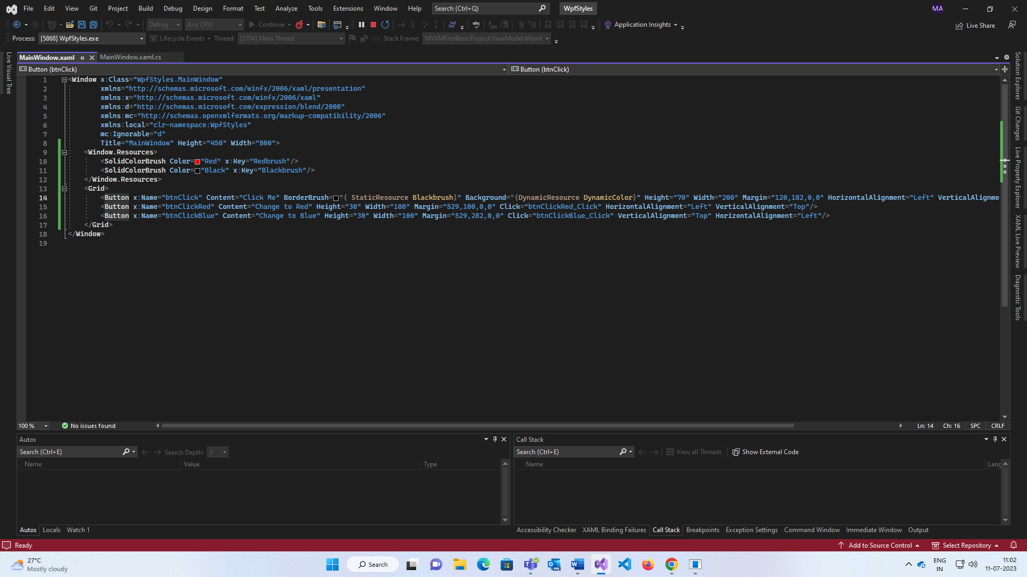

Without re compiling the application we can change.

E.g., Localization languages

**Data Templates:**

It is responsible for visualisation data. If we represent an object into UI we should use Data Templates. It is used as a resource.

We have define the data templates otherwise WPF doesn’t understand how to represent the object on the screen, therefore it calls .ToString() method and shows that class object with the namespace.

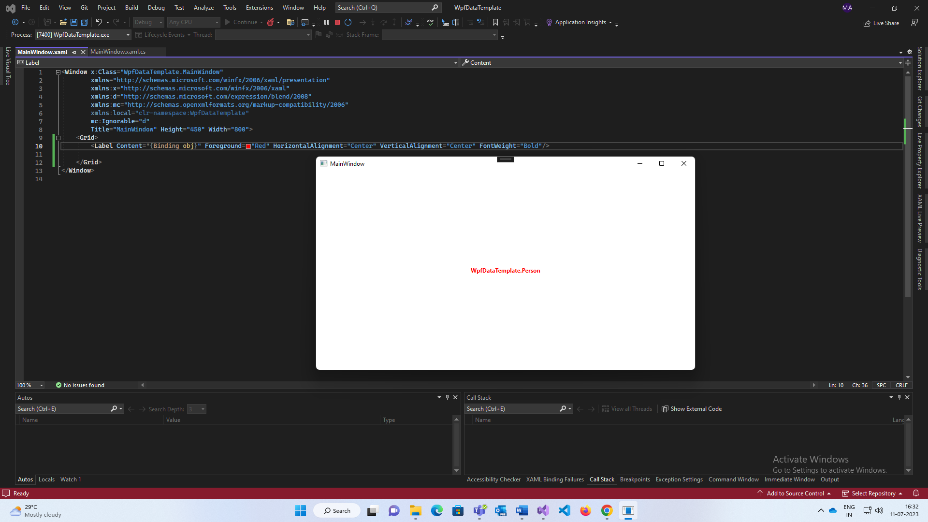

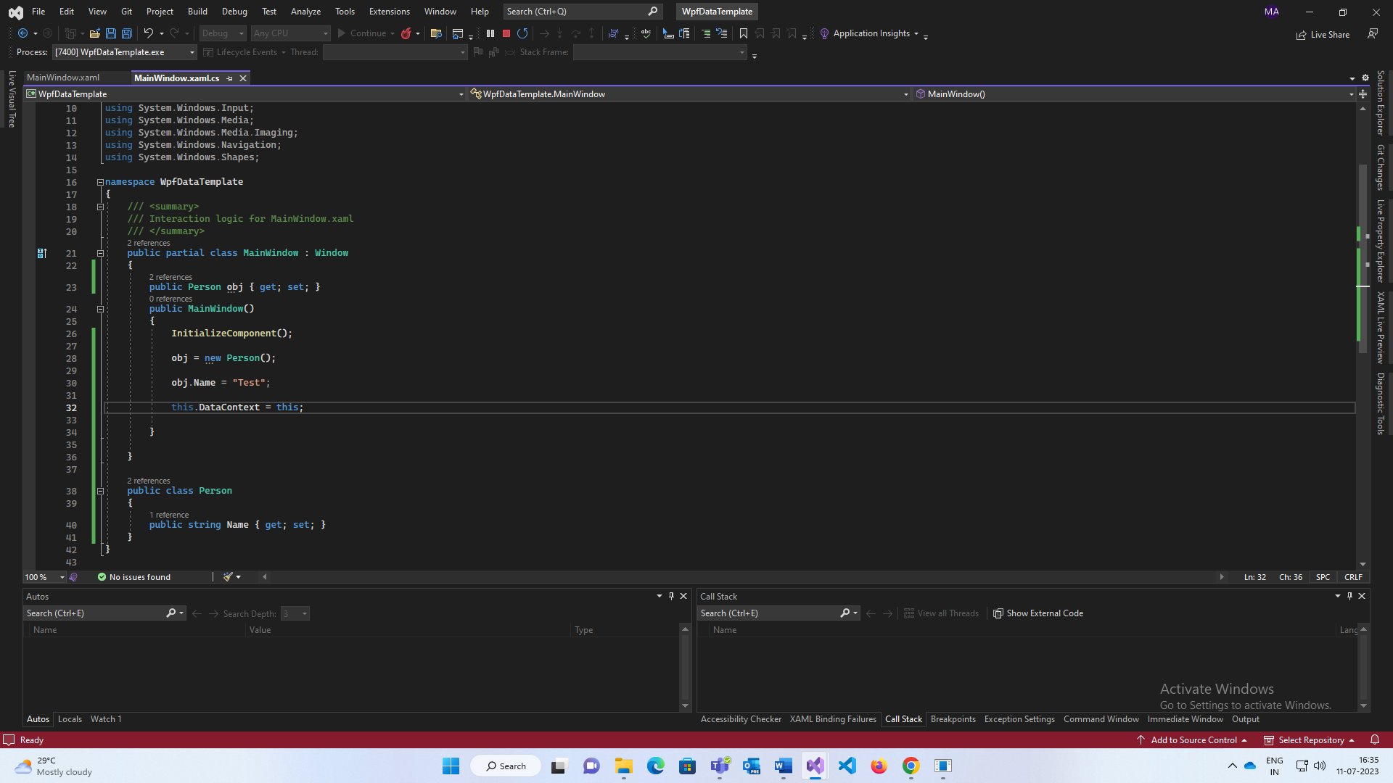

To overcome this

1. just override the ToString() method (if there will be many obj we have to override that much time)

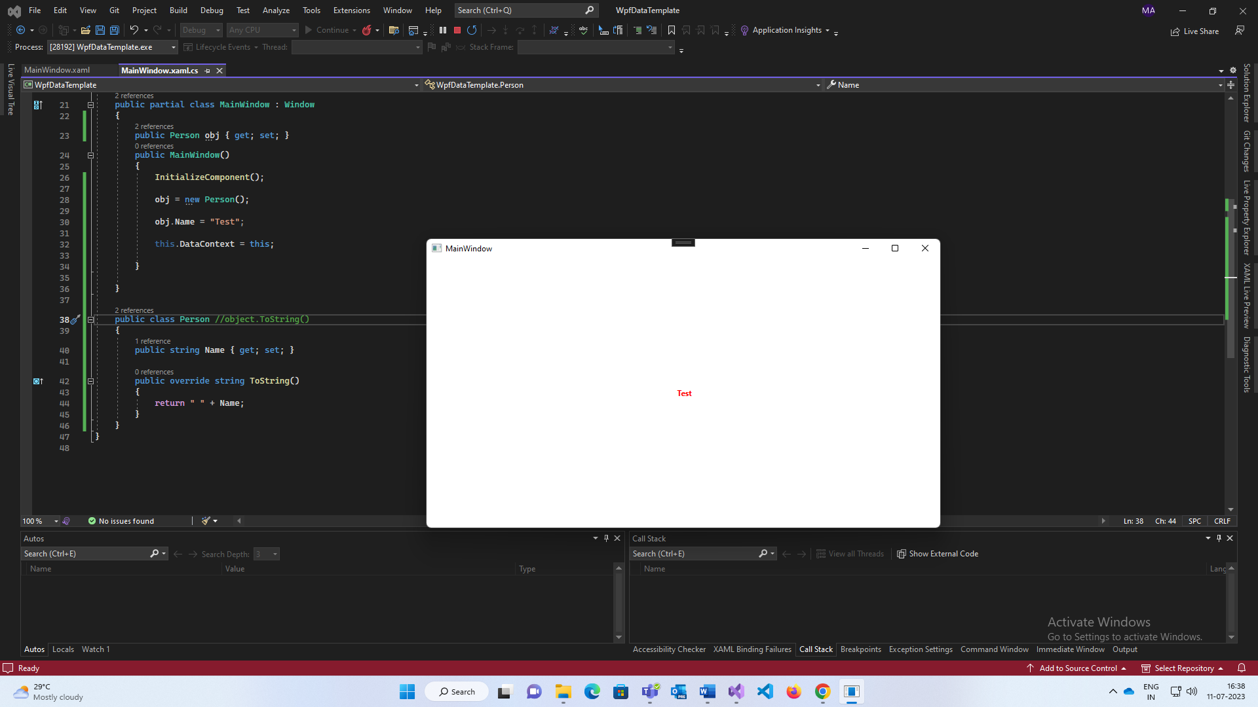

or

2. Using Data Templates

<ContentTemplate> markup where data templates are defined.

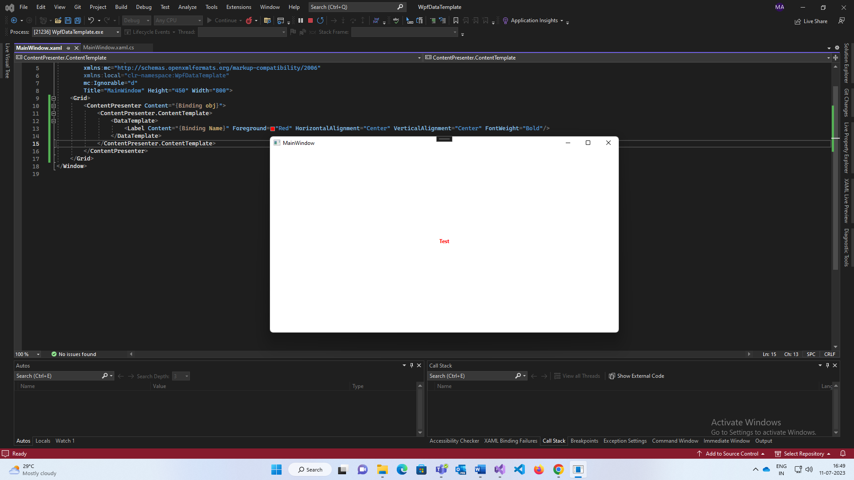

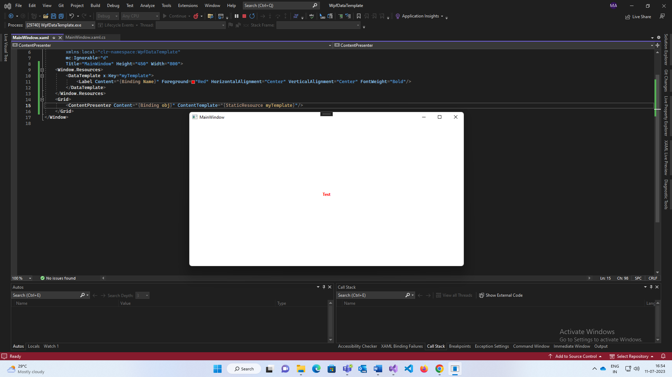

**Style:**

Like external CSS, one style so we can use again and again. It has collection of property value that can be applied to an element.

<style TargetType= “Button/Calender” (x:key= “ “)>

</style>

Explicit Styling, we must define a key.

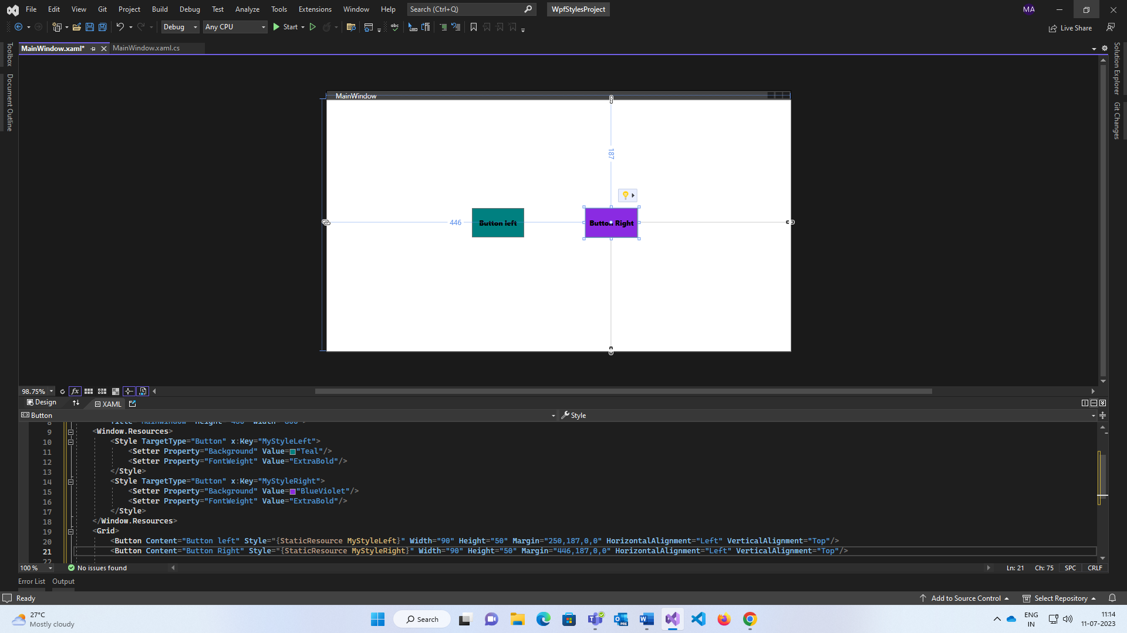

It can be applied in app.xaml file for whole application.

For single button applying styles

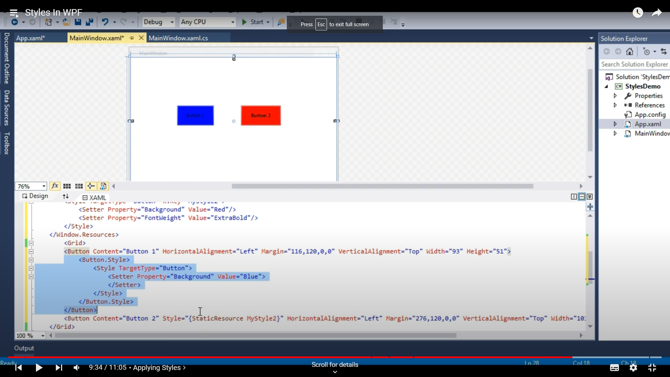

Inside that button tag.

Implicit Styling, we don’t need key. It will apply every control of the window which is specified as the target type.

Style Inheritance is achieved by BasedOn keyword.

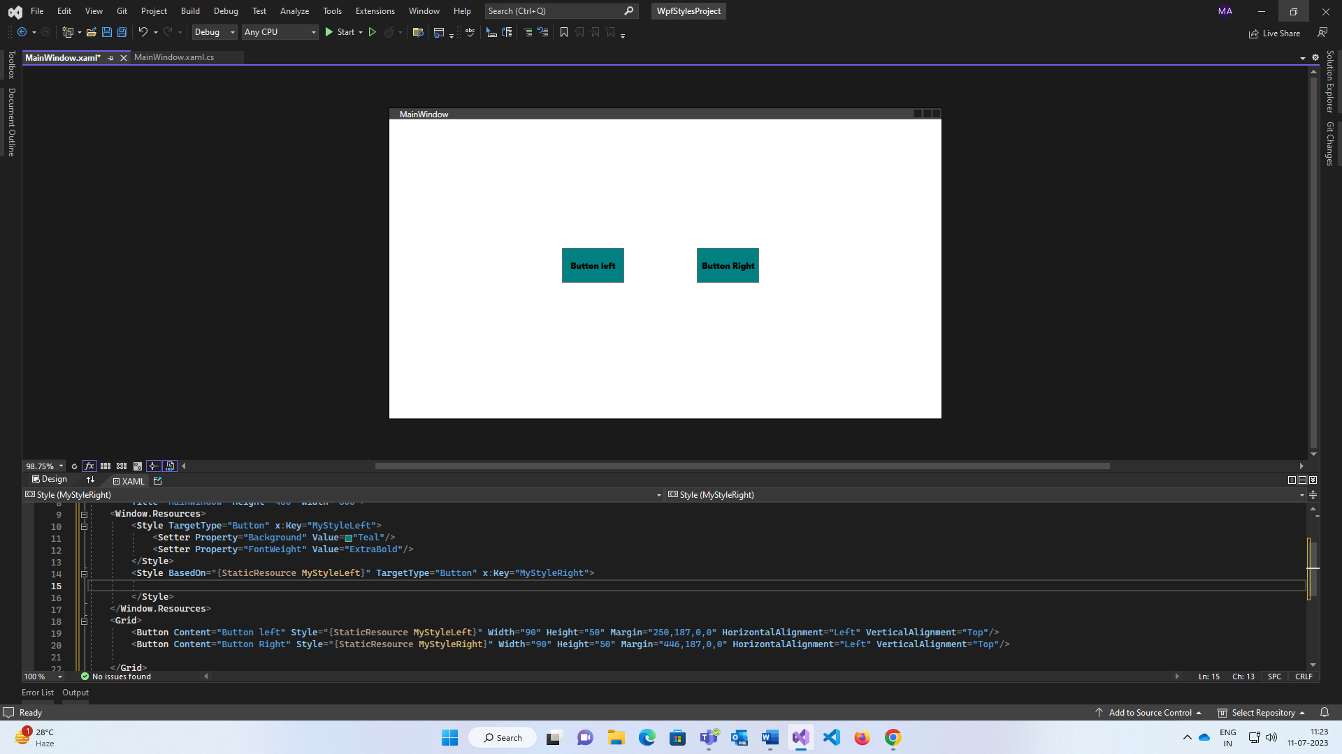

Setter for static and Trigger for dynamic

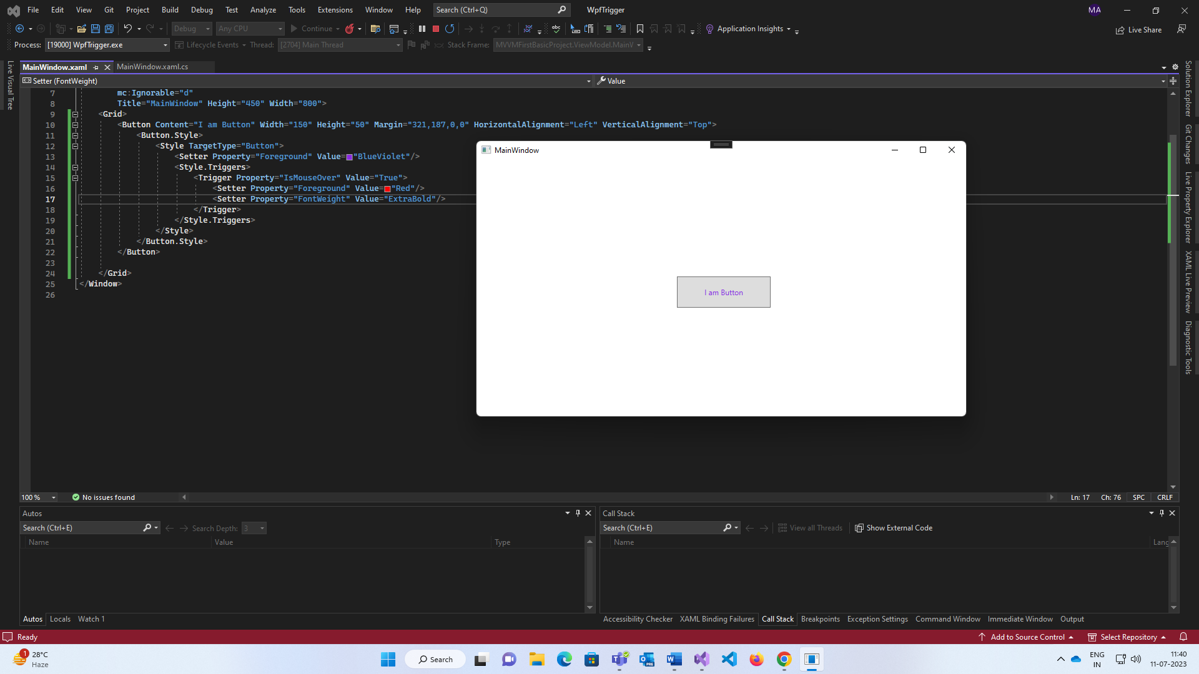

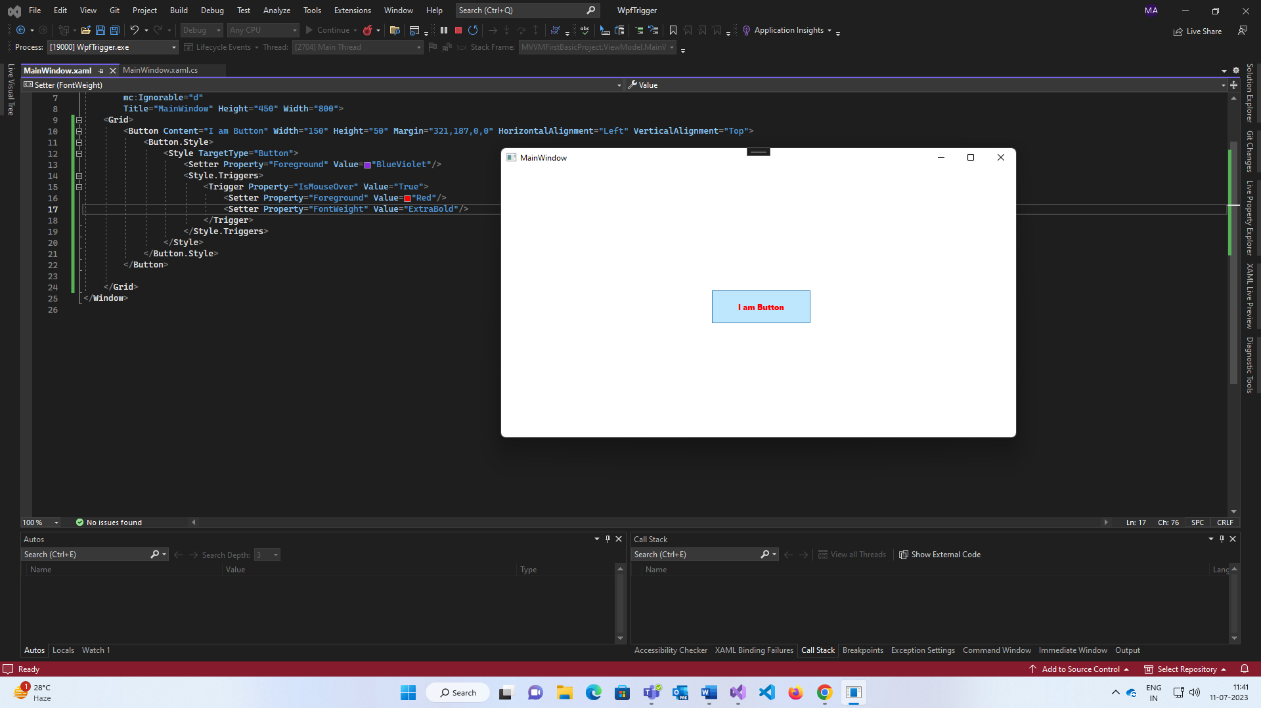

Trigger🡪 Internally it uses dependency property.

<Style.Trigger>

1. Property trigger 🡪 it will change conditionally. True > change and False > reverts.
2. 3.Event Trigger🡪 normally add animation then we can use it.
3. Data trigger🡪 not necessarily dependency property, then data trigger is used. Binding a property alike as after IsChecked the box then it will change.

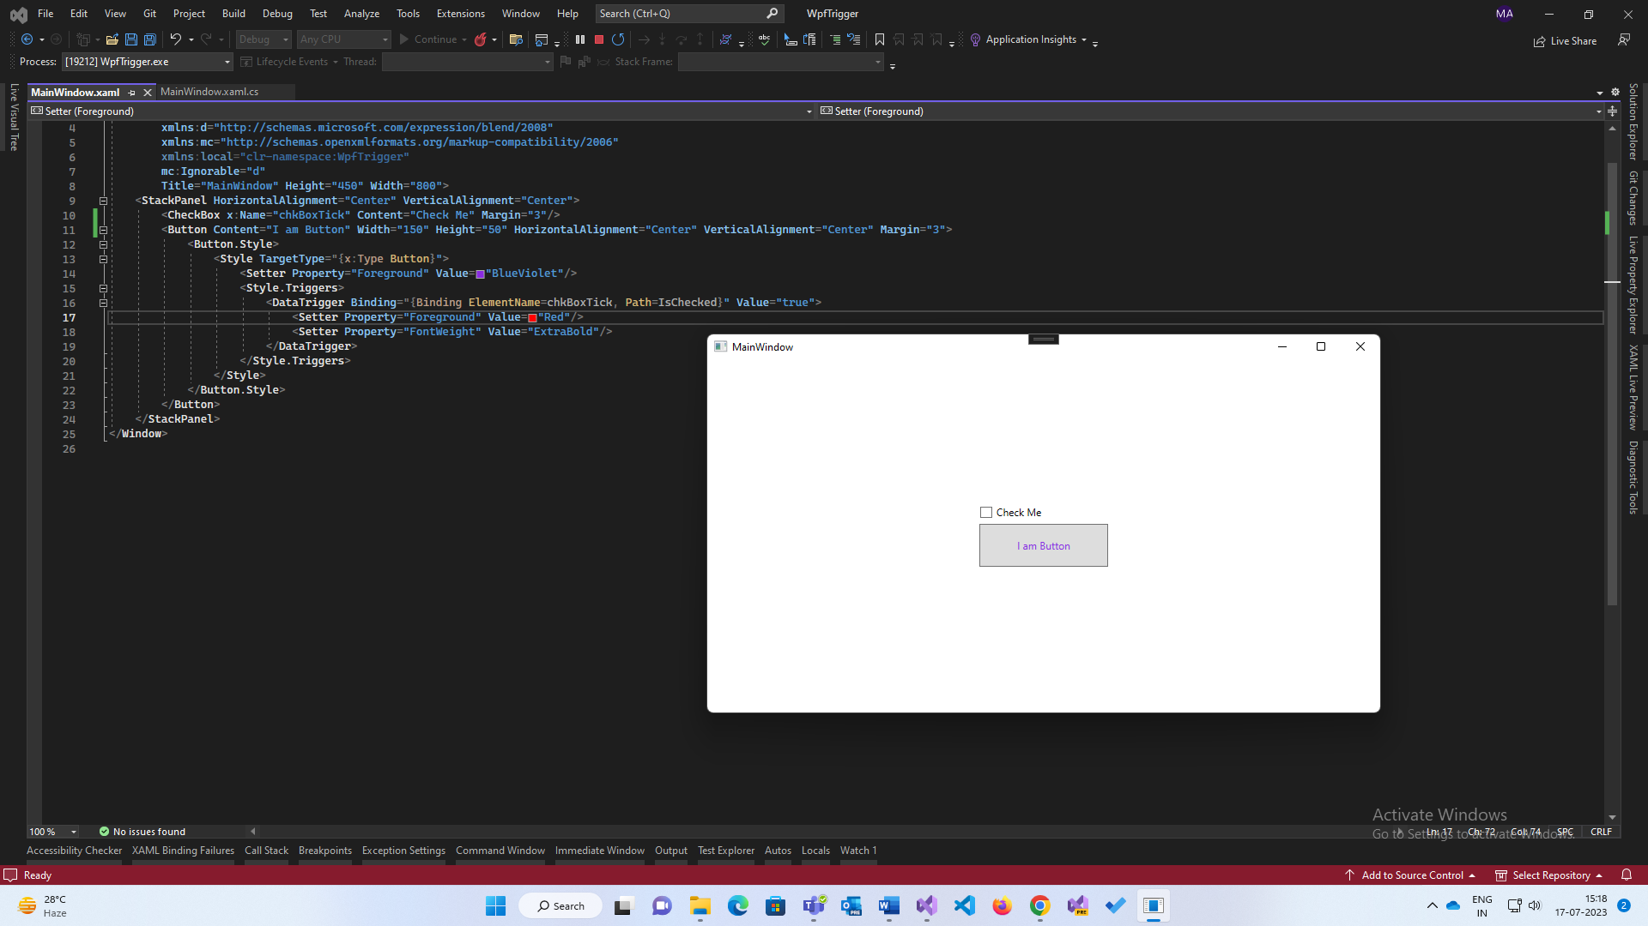

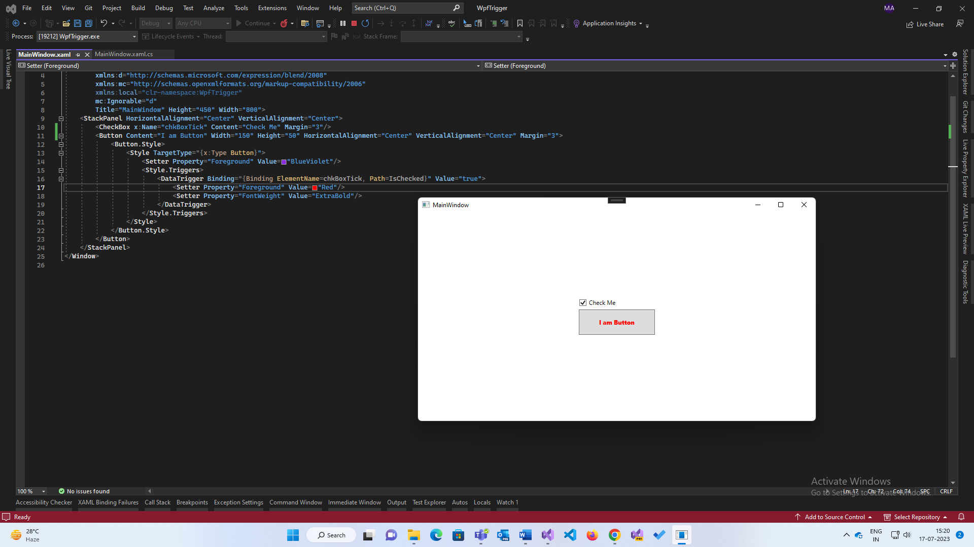

**Dependency Properties:**

It used in conjunction with normal CLR Properties (normal property + extra Wpf features) with change notification. D.P. is wrapped inside a normal CLR property.

It is used for data bindings, stylings, validation, call back functions.

It wrapped as a normal CLR property.

Conventional name always ends name with property.

In built sealed class named Dependency Property.

Button class has a dependency property background property.

Static and readonly. Static because we don’t want create object again and again, always be shared and available for all controls in app. Readonly because it’s values should not be changed after initialization.

Propdp and press tab twice.

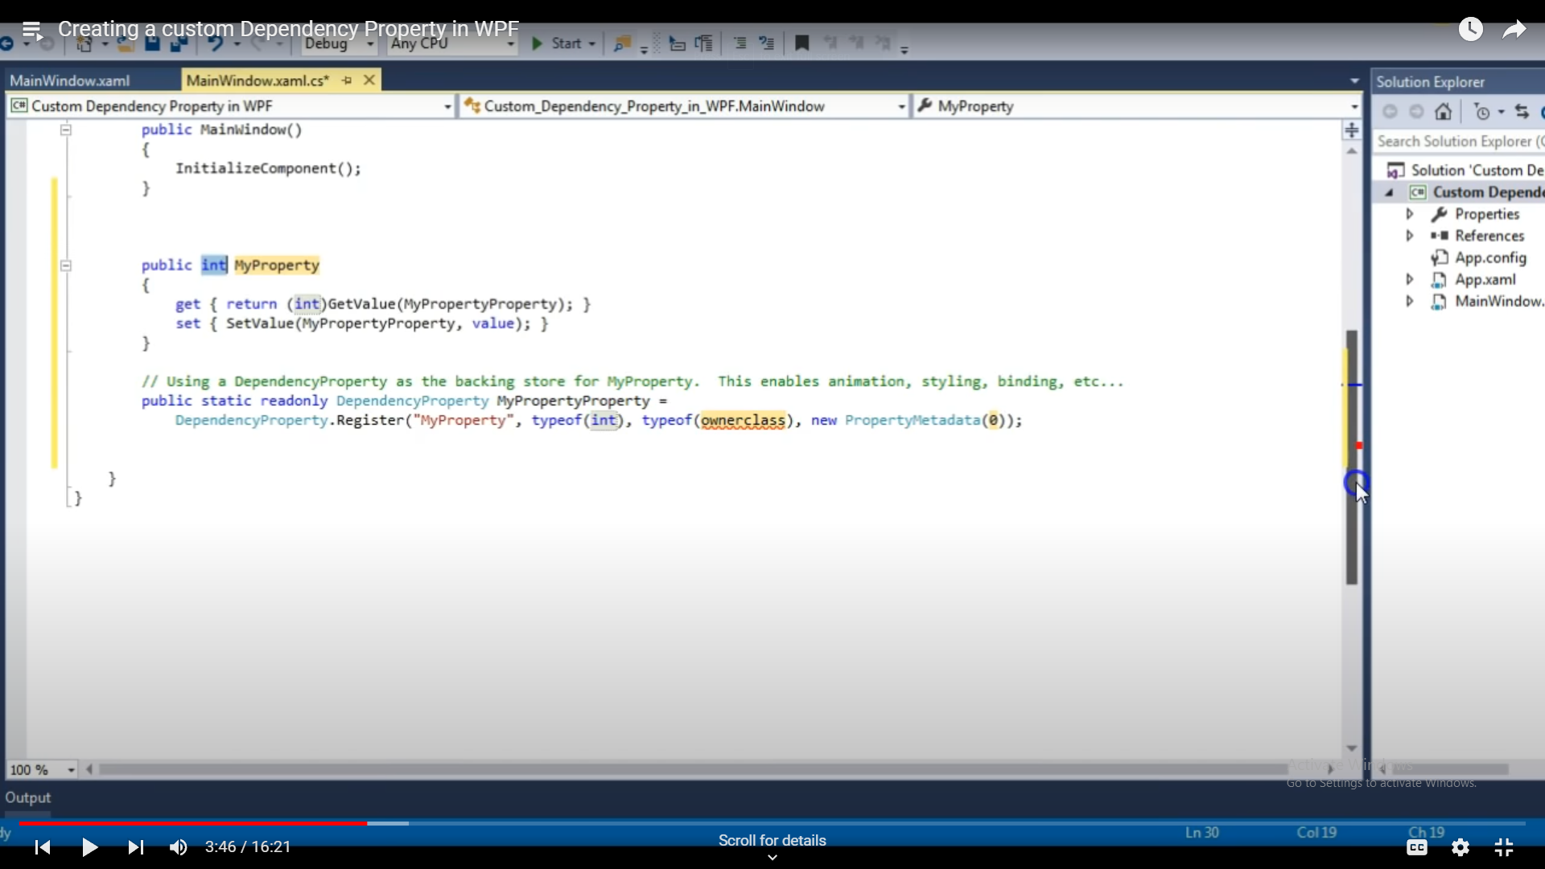

**Attached Properties:**

Special type of dependency property, it can be added to any object.

If it needs to apply on to the control itself, then create a dependency property but if it needs to apply on to the children of that control, then create an Attached Property.

Eg. Grid is dependency property but grid.row and grid.column is attached property which is applied inside the grid.

Propa and tab twice.

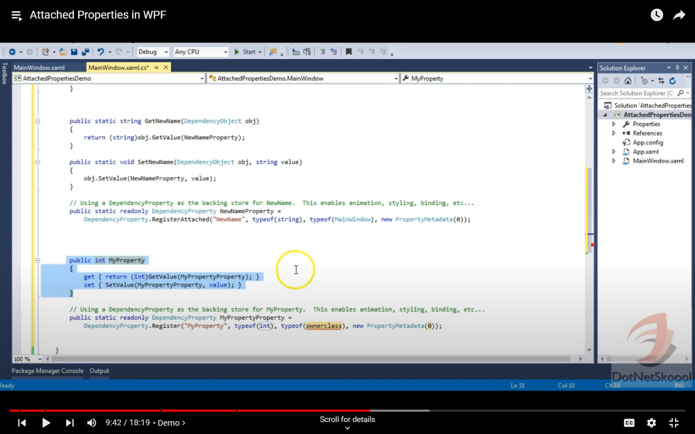

**Attached property Vs Dependency property.**

A.P. registered using RegisterAttached() method of dependency proproperty class and D.P. registered using Register() method.

A.P. wrapped and access with static methods for getter and setter and D.P. wrapped inside normal CLR prop and access thro’ getter and setter.

**INotifyPropertyChanged Interface:**

Present in System.ComponentModel namespace, this interface is notifying the UI that our property has changed and need to update yourself.

While implementing this interface we get: public event PropertyChangedEventHandler PropertyChanged;

Its event is raised when the property is being changed. To raise this, we need to write a method.

private void OnPropertyChanged(string propName)

{

if (PropertyChanged != null)

{

PropertyChanged(this, new PropertyChangedEventArgs(propName));

}

}

new PropertyChangedEventArgs

this eventsargs class is responsible for the raising the event, always I am raising a new event.

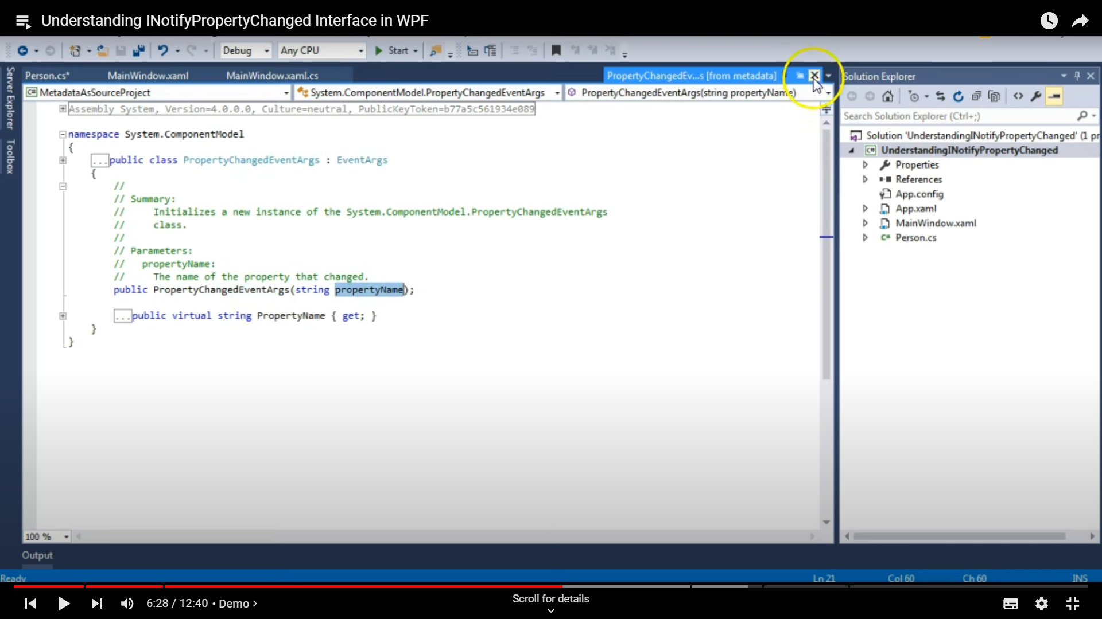

Or we can derectly write,

private void NotifyPropertyChanged(string propName)

{

PropertyChanged.Invoke(this, new PropertyChangedEventArgs(propName));

}

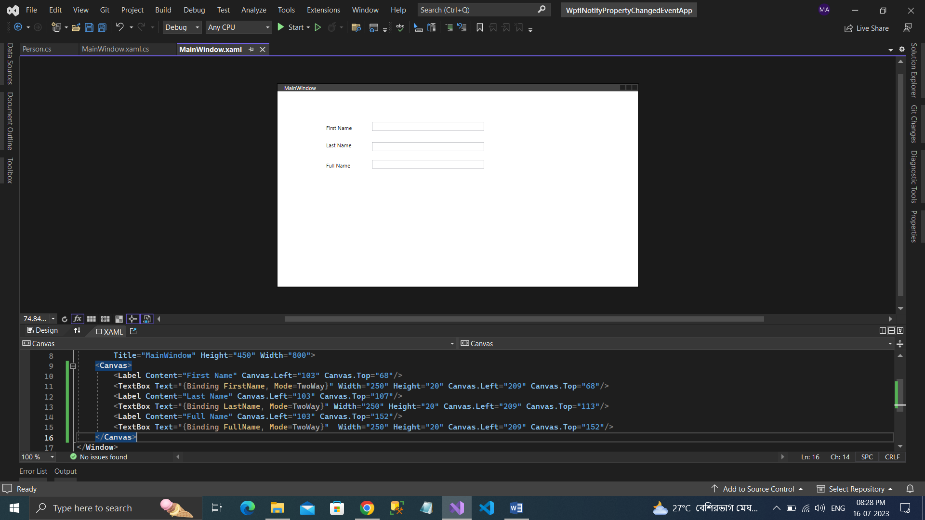

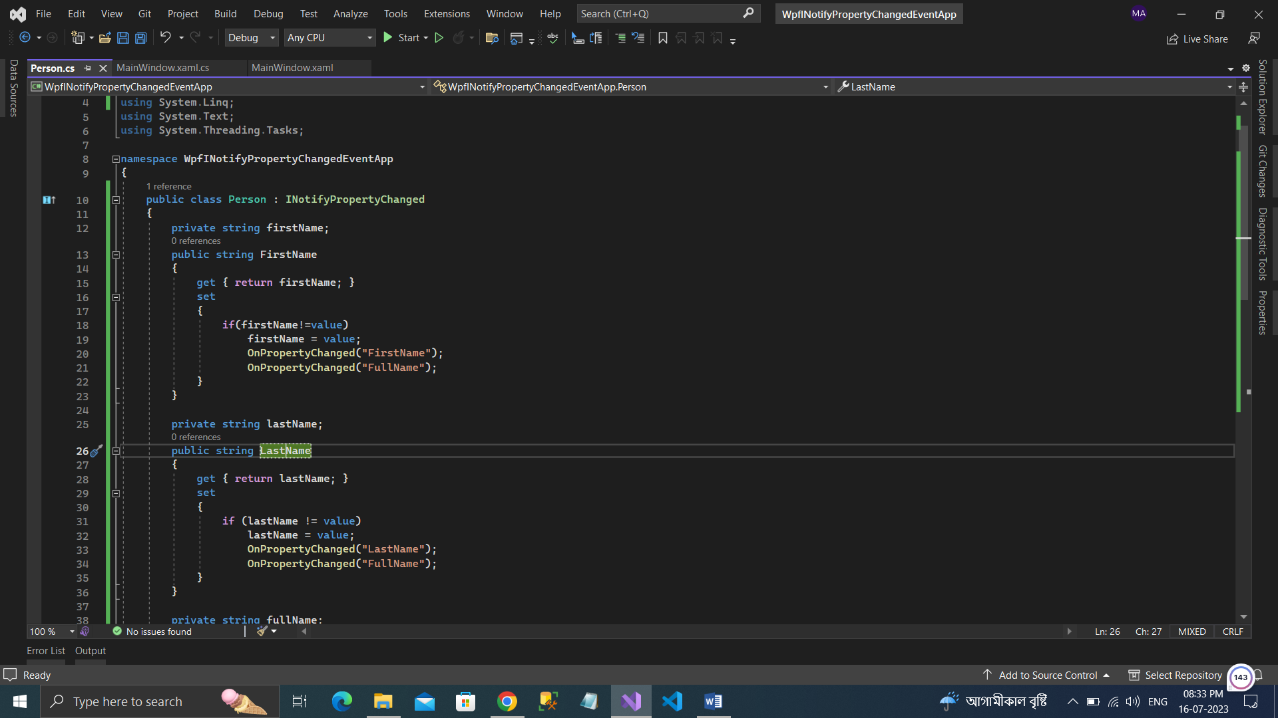

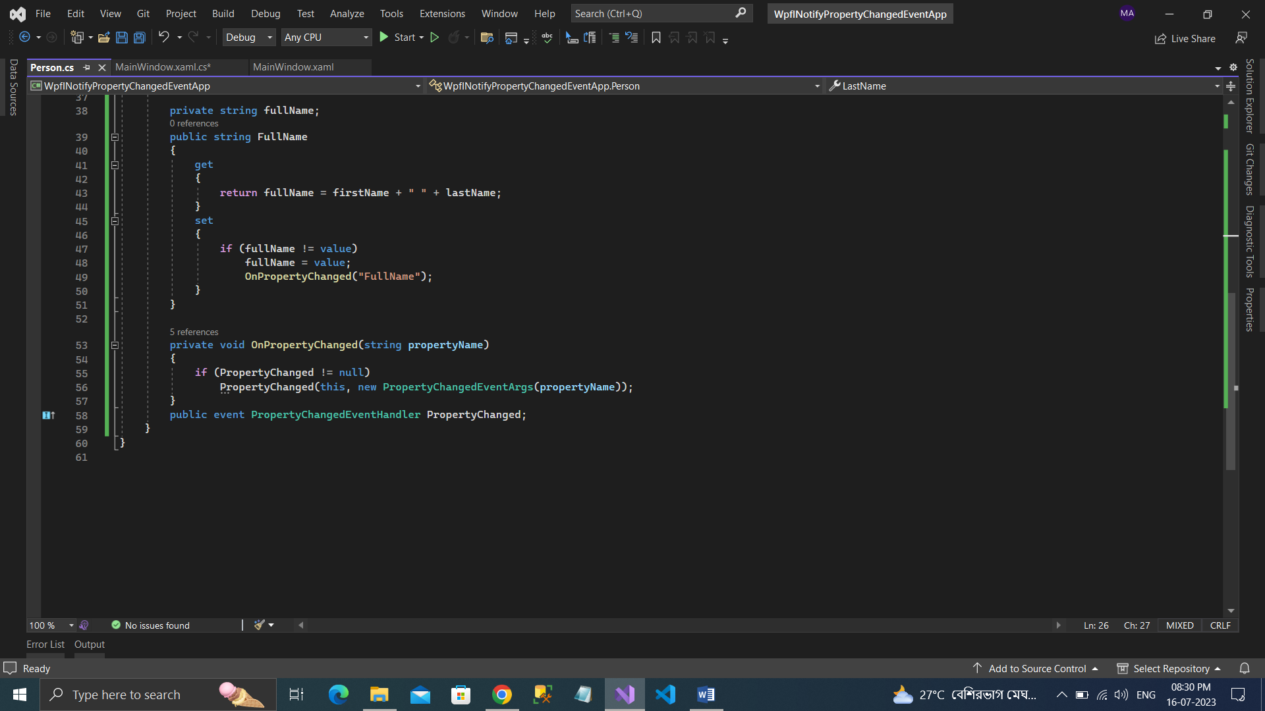

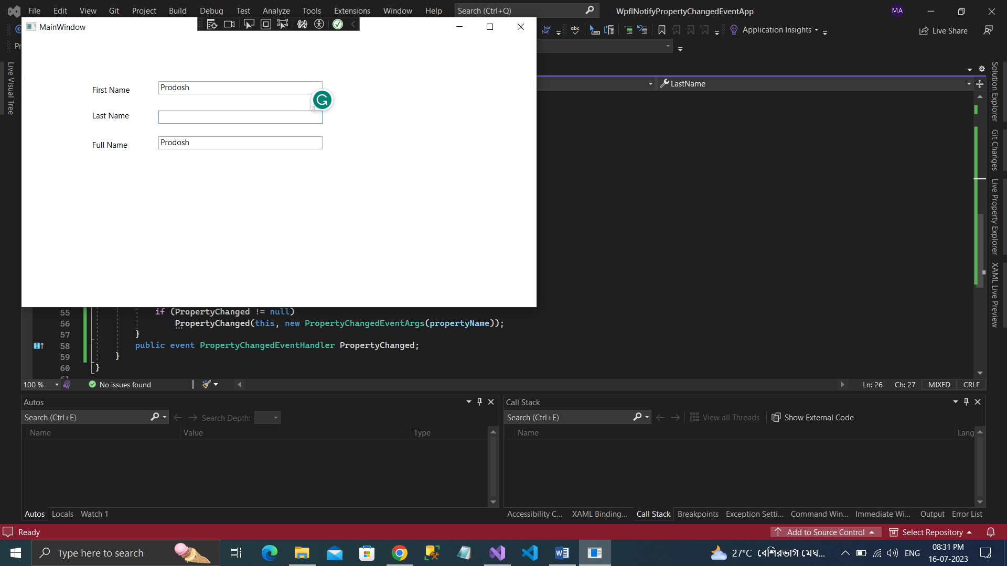 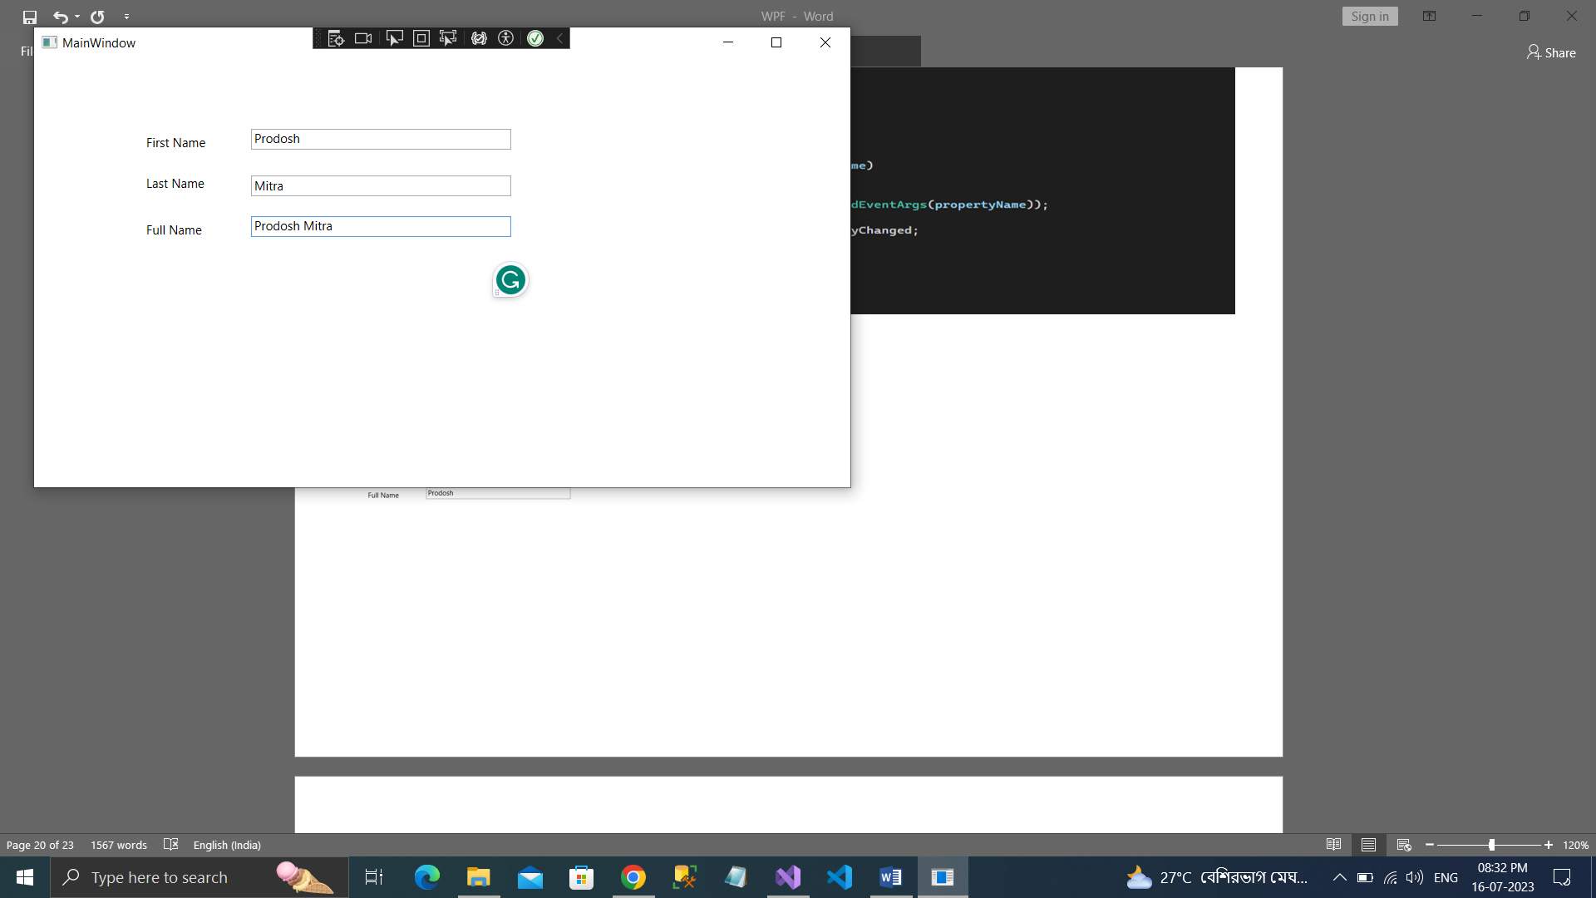

**DataGrid:**

A grid is a panel which holds elements of Wpf screen and DataGrid is the control which is responsible displaying the data in UI.

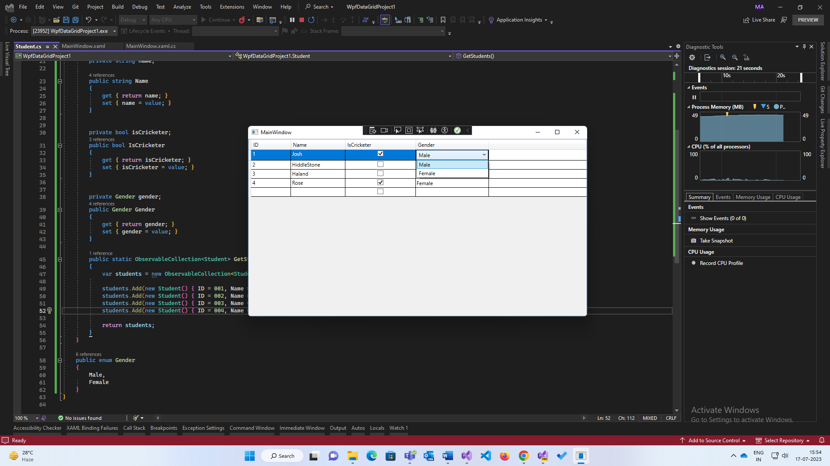

In Xaml

<DataGrid Name="StudentDataGrid"/>

For externally if I need column name then, I can design like this.

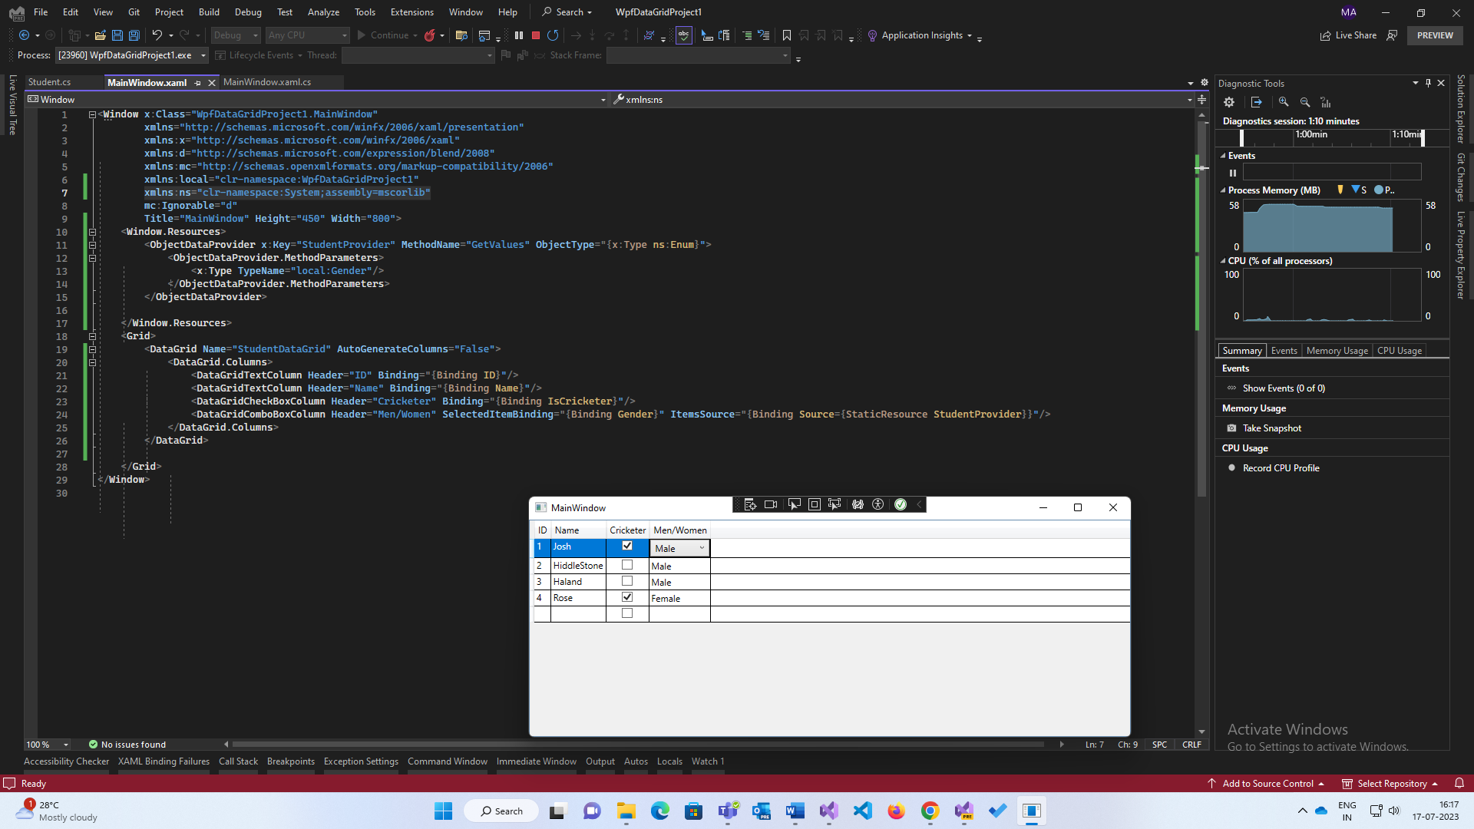

**IDataErrorInfo:**

Validation purpose used. This interface reports error and also, we avoid code behind logic.

Present in System.ComponentModel.

This interface has two properties named Error and one property which refers to current object if class (to write validation rules).

**Value Convert:**

Convert value of data binding operation.

Interface **IValueConverter** present in System.Windows.Data. It has Convert() manipulates the data binding that is done on to our code and change values.

ConvertBack() reverts it with help of TwoWay bindings Only.

**User Control:**

To get rid of UI duplication it is used, reusable window and code reusability.

<UserControl.Resources>

**Dispatcher:**

WPF is based on Single threaded apartments which contains only one thread. For different thread accessing scenarios we can use explicit delegates (which is owned by UI thread) and callback functions/methods.

Dispatcher class do same thing, which is in built class in WPF, it has Invoke method with has action callback readymade.

**Controls templets:**

It allows to specify the visual structure of a control.

On customizing the controls, the content of controls is lost because WPF is not sure where to place the content and this problem is solved with **ContentPresenter**.

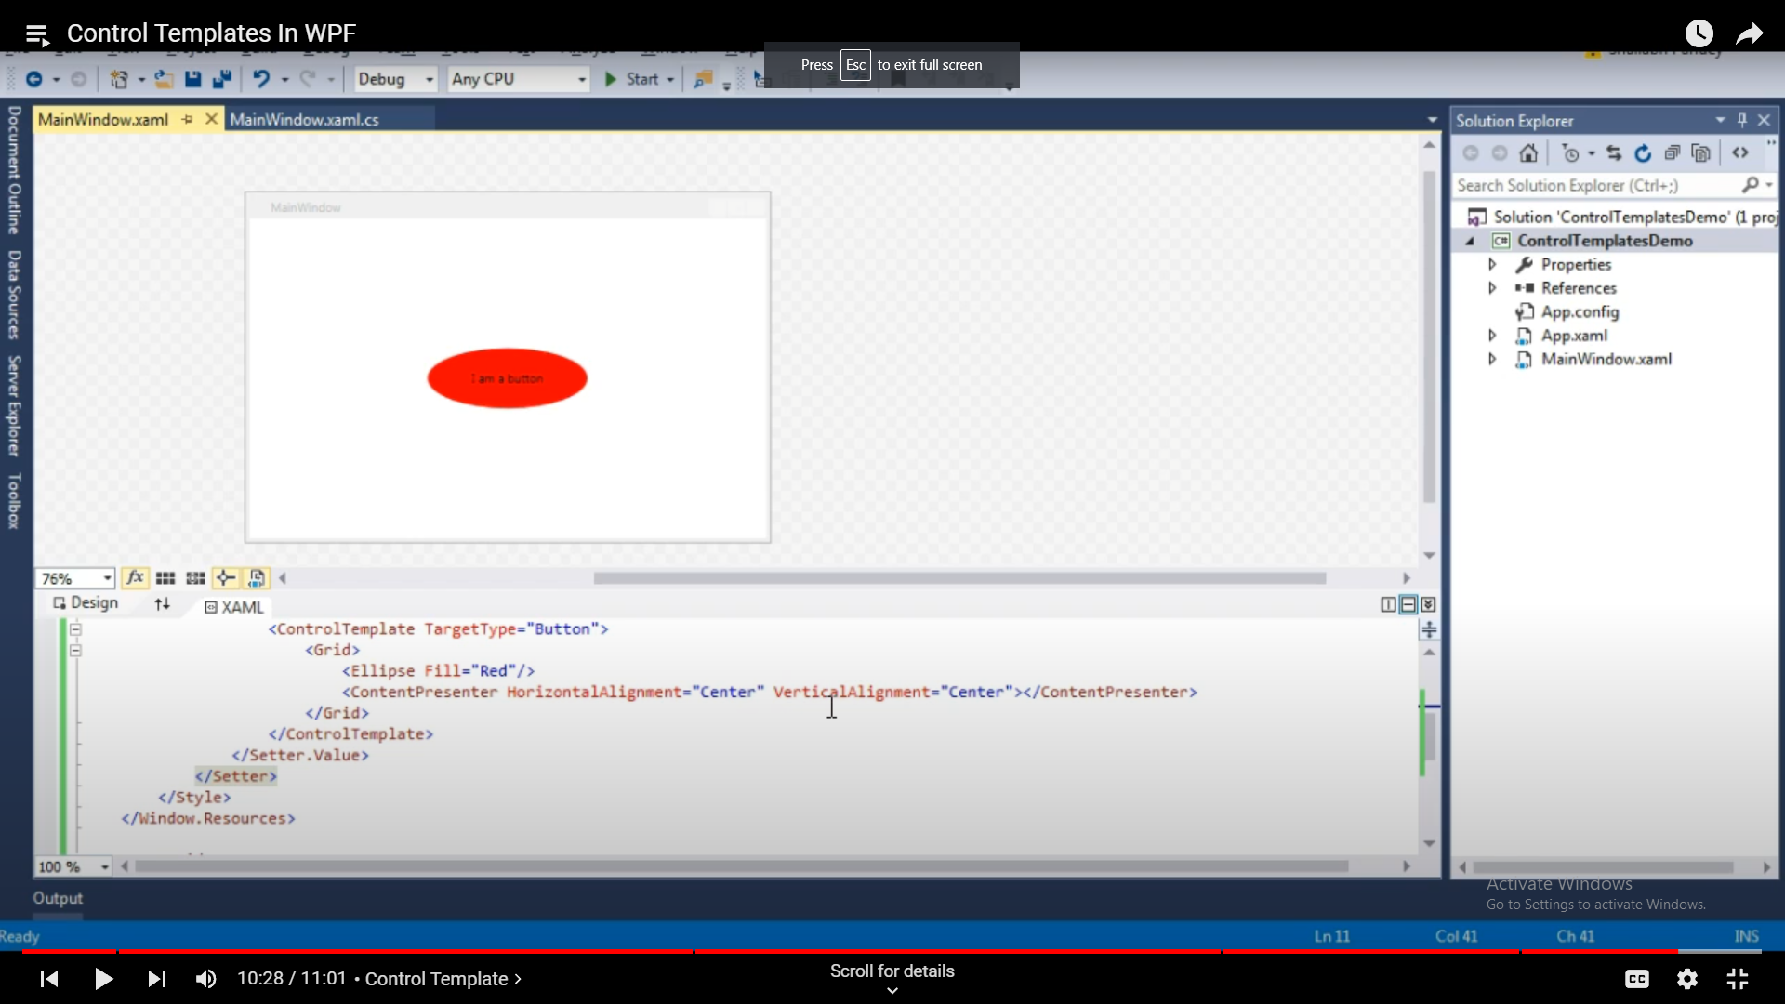

Control templates are generally applied with styles and triggers.

in a style we set property of a control but in control template we define the UI of the control and use properties, values that are set in the style.